Zoonotic Disease Vocabulary Puzzle
 |  |  |  |  |  |  | S ¹ |  |  |  |  |  |  |  |  | A
 |  |  |  | E |  |  | ² | R
 |  |  |  |  |  |  | ³ |  | G
 |  |  |  |  |  |  | A ⁴ |  |  | Y
 |  |  |  |  |  | C | ⁵ | Y
 |  |  |  |  |  | V | ⁶
 |  |  | P |  |  |  | T ⁷
 |  |  |  | F |  | V | ⁸
 |  |  |  | B |  |  | S ⁹ |  | C |  | R |  |  | Y
Q |  |  |  |  |  | T | ¹⁰ |  | E
 |  |  |  |  |  |  | C ¹¹ | O
 |  |  | T |  |  | C | ¹²
 |  | B |  |  |  | B | ¹³
 |  |  |  |  | H |  | ¹⁴ |  | W |  |  |  |  | N | G
 |  |  |  |  |  |  | I¹⁵ | N |  |  | U |  |  | Z
 |  |  |  |  | S |  | ¹⁶ |  | T |  |  | S
 |  |  |  |  | H |  | ¹⁷ | L |  |  | Y
 |  |  |  | E |  |  | L¹⁸
 |  |  |  |  |  |  | S¹⁹ | C

Word List:
Ascaris
Biosecurity
Boot Bath
Campy
Cough
Crypto
E coli
Enteric
Fever
Handwashing
Healthy
Influenza
Salmonella
Pig
Poultry
Quarantine
Symptoms
Vaccine
Track

- _________ lives inside your poultry and reptiles.
- _________ is a type of disease that causes stomach illness.
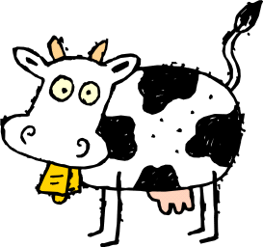
- _______ is another word for swine.
- An enteric that lives in the intestines of healthy poultry.
- ___________ lives in the intestines of cows and calves.
- The best way to prevent the flu is to get a __________ .
- Chickens and turkeys are examples of _____________ .
- A common sign of illness is a ______________ , measured with a thermometer.
- ____________ is taking extra care to prevent disease by keeping things clean.
- If you separate a sick animal completely, you put it in _______________ .
- A common flu symptom in pigs and people is ___________ .
- If you don’t change or bleach your boots, you’ll __________ pathogens around the farm.
- ___________ is what you use to clean your boots after taking care of your animals.
- _______________ is the best way to prevent the spread of enteric disease.
- Flu is the nickname for the ______________ virus.
- Watch for ___________ to know if you or your animals are sick.
- Keeping your farm _________ is easy when you practice good biosecurity.
- ______ produces a Shiga toxin, and lives in the intestines of ruminants, like cows.
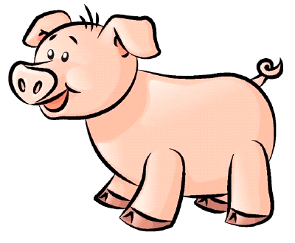
- The pig roundworm is called ____________ .
Secret message:
S __ __ A __ __ T __ S __ C __ __ __ I __ __ L S

