EF-M-39 A&B – Allocation of Subsidy for Adult Education Students

All public SAUs, excluding Public Charter Schools, must report even if there are no pupils to report.
Data entered into this report are based on the number of Resident Students from SAUs who are attending Regional Adult Education Programs. Students attending Adult Education Programs under Superintendent Agreements are reported by the attending SAU. This report is only intended to include students aged 16-20 years old who have exited regular education, and are alternatively taking Adult Education courses. These reporting parameters are outlined in Title 20-A, §8605: Adult Education Eligibility
There are two reporting ranges for EF-M-39
EF-M-39A | EF-M-39B
Reporting Range: January 1-June 30  Due Date: July 15 | Reporting Range: July 1-December 31  Due Date: December 15

NEO Navigation steps:
NEO -> Student Data -> Adult Education EF-M-39 -> Adult Education EF-M-39
**If you do not have NEO credentials, your Superintendent must submit a NEO Access Request Form on your behalf. Staff who require NEO accounts/access must be entered into NEO Staff prior to submitting an Access Request.
- Sign into NEO
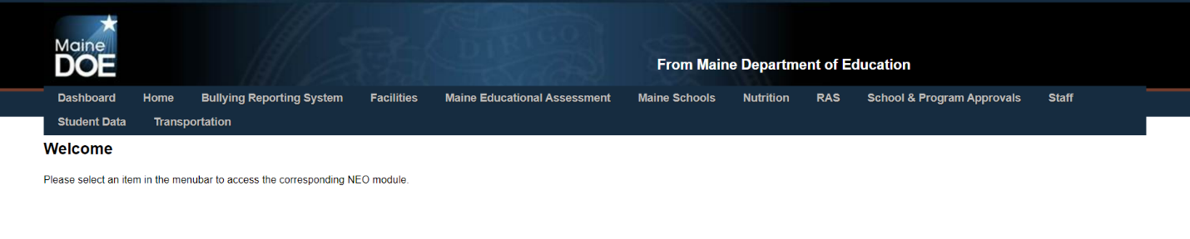
- Select Student Data
2

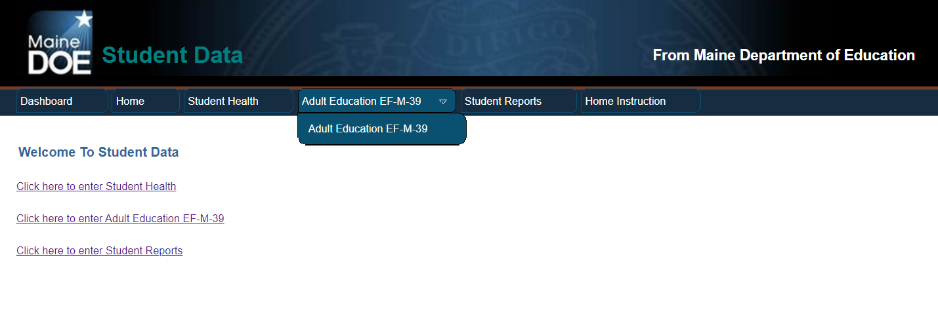
- Select Adult Education EF-M-39 from either the Student Data dashboard or from the dropdown at the top of the screen.
3
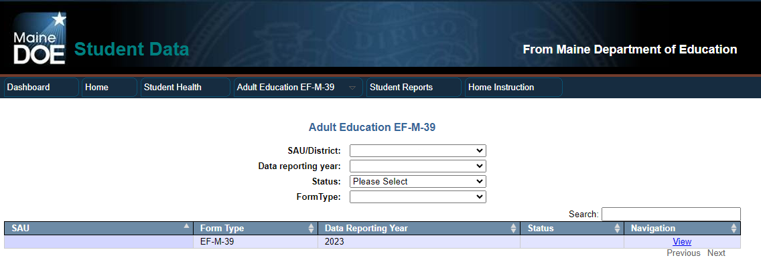
- Select your SAU/District, Data Reporting year, and Form Type then select Create or View under Navigation to review the EF-M-39 Report for your selected SAU.
4
- Select whether SAU has students to report - Yes or No
- Enter Student Data based on resident students aged 16-20 years old who are no longer enrolled in regular education and are alternatively taking Adult Education courses.
  - Enter the total number of students (between the ages of 16-20) enrolled in adult education
  - Enter the total number of courses in the spaces provided
  - Enter the total number of credits

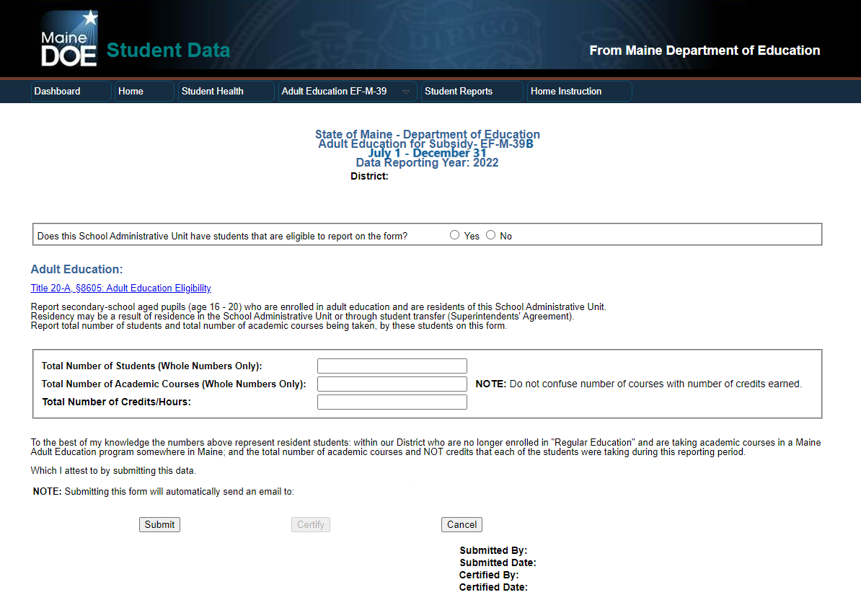
5
6
If you have questions about this report please contact MEDMS.Helpdesk@maine.gov or call 207-624-6896

