Teacher Performance Evaluation and Professional Growth (T-PEPG) Model
Facilitator Guide for Training Module 2: Student Learning Objectives

Teacher Performance Evaluation and Professional Growth (T-PEPG) Model
Facilitator Guide for Training Module 2: Student Learning Objectives
November 2014

Contents
Page
T-PEPG Modules: Purpose and Goals 1
Audience 1
Timing and Structure 1
List of Training Modules 2
Preparing for Module 2 4
Module Overview 4
Intended Outcomes 4
Agenda 1
Equipment and Materials 2
Maine DOE Model Resources 2
Facilitator Guide 3
I. Welcome and Overview (5 minutes) 3
II. Connecting (20 minutes) 4
III. Learning (1 hour, 25 minutes) 10
IV. Implementing (50 minutes) 22
V. Reflecting (10 minutes) 24
VI. Wrap-Up (10 minutes) 24

T-PEPG Modules: Purpose and Goals
This series of five T-PEPG modules is designed to provide teachers with information and guidance on the Maine Department of Education (Maine DOE) Teacher Performance Evaluation and Professional Growth (T-PEPG) model, which is being implemented in their schools. T-PEPG Leads and the administration (if necessary) will train the Professional Cohort facilitators, who will then train teacher participants using the module materials. The module materials are intended to:
- Make the four-step T-PEPG process meaningful, doable, concrete, and actionable for teachers
- Support teachers in developing a common understanding of the evaluation model, the MSFE Rubric, and the opportunities for professional growth and development grounded in the five National Board Core Propositions
- Provide participants with tips, strategies, and opportunities to share best practices aligned with the T-PEPG model
The T-PEPG modules provide facilitators with consistent, standardized materials and content, detailed facilitator guides, and participant handouts that align with the T-PEPG model. Facilitators may use some or all of these materials and may modify them as appropriate to meet teachers’ needs and accommodate the amount of available time.

Audience
The T-PEPG modules will be presented to teachers by Professional Cohort facilitators in their respective schools. Districts and schools can determine whether to bring educators together for a schoolwide or districtwide training session or provide training to smaller, grade-level or content-area teams.
The modules are designed so that Professional Cohort facilitators can facilitate abbreviated, chunked, or complete versions of each module to teachers, as necessary (see the section on timing and structure for more details).

Timing and Structure
Each training module varies in length (from two to three hours) and includes interactive learning activities, which were designed within a framework of adult learning theory and best practice. Suggested assignments described at the conclusion of each module are intended to help participants extend and apply their learning and are designed to be integrated into the work teachers are already doing. Each module allocates time for participants to share what they have learned as a result of completing the assignment and collaborate on the appropriate next steps.
The modules are organized into four parts to help facilitators and participants pace the content appropriately. The four segments of each module are as follows:
- Connecting—Builds community, prepares the team for learning, and links to prior knowledge, other modules, current work, and the MSFE Rubric; designed for all school-based educators
- Learning—Describes key concepts and highlights various implementation scenarios; supports teams in applying knowledge and sharing ideas; designed for all school-based educators
- Implementing—Supports teams in problem solving and planning next steps for schools and districts; geared toward school leadership teams
- Reflecting—Engages participants in providing feedback, reflecting on learning, and closing the session

List of Training Modules
Module 1: Model Overview. The first module provides participants with a big-picture overview of the key features of the T-PEPG model, including its purpose and goals, timelines, and annual process; the National Board of Professional Teaching Standards (NBPTS) Core Propositions; multiple measures of effectiveness; summative scoring; and professional growth plans. Participants unpack the basic structure and terminology of the MSFE Rubric and examine the rubric’s standard indicators in preparation for self-assessment, reflection, and goal setting, which is covered in Module 3.
Module 2: Student Learning Objectives. The second module engages participants in the student learning objective (SLO) development process. Knowing how to set realistic and rigorous targets is critical for supporting student learning throughout the year. SLOs are specific and driven by needs, and they include an instructional plan that enables students to meet their learning targets. SLOs also inform teachers’ professional goal setting, which is covered in Module 3.
Module 3: Reflection and Goal Setting. The third module supports participants in reflection in order to set professional goals. Participants engage in SMART goal development, a process that can help teachers achieve or maintain effective practice and ensure students meet the rigorous learning targets established through the SLO process. Professional growth is one of the multiple measures of the T-PEPG model, and SMART goals provide participants the opportunity to strategically identify specific areas of growth and focus for the school year.
Module 4: Evidence, Observation, and Feedback. The fourth module describes expectations for observations (both inside and outside classrooms), the collection and organization of observation evidence, and the sharing of timely, constructive feedback. All participants engage in peer observation, and the module provides information about how to make the process meaningful, collaborative, and constructive.
Module 5: Reflecting and Adjusting. The fifth module supports participants in the use of the MSFE Rubric, evidence, and student data to monitor progress toward their professional goals. Participants explore when and how to revisit their professional goals, check in on student progress, and collaboratively determine appropriate midcourse adjustments to their practice. The module includes an extension section that facilitators can use as needed to prepare teachers to gather evidence in preparation for the summative evaluation conference and as a tool to guide reflection and future goal setting. The section also includes an overview of the summative scoring process and professional growth planning process.

Preparing for Module 2

Module Overview
The second module engages participants in the SLO development process. Knowing how to set realistic and rigorous targets is critical for supporting student learning throughout the year. SLOs are specific and driven by need, and they include an instructional plan that enables students to meet their learning targets. Through multiple activities, participants will increase their understanding of the SLO process and will have time to begin drafting their SLO for the 2015-16 school year. SLOs will also be used to inform teachers’ professional goal setting (covered in Module 3).

Intended Outcomes
At the end of this session, participants will be able to:
- Understand the SLO process and explain their role in it
- Understand the Maine DOE guidance for developing an SLO
- Use the SLO template checklist to review an SLO
- Draft an SLO that is specific to their respective content areas

Agenda
- Welcome and Overview (5 minutes)
- Connecting (15 minutes)
- Connecting Content: What Is an SLO?
- Connecting Activity: SLOs and Core Propositions: What’s the Connection?
- Connecting Wrap-Up/Debrief
- Learning (1 hour, 25 minutes)
- Learning Content 1: The SLO Process
- Learning Activity 1: Breaking Down the SLO Template
- Learning Wrap-Up/Debrief 1
- Learning Content 2: Using the SLO Template and Checklist
- Learning Activity 2: Reviewing a Complete SLO
- Learning Wrap-Up/Debrief 2
- Learning Activity 3: SLO Quiz Show
- Learning Activity 4: Feedback Carousel
- Learning Wrap-Up/Debrief 4
- Implementing (50 minutes)
- Implementing Activity 1: Writing Your SLO
- Implementing Wrap-Up/Debrief
- Reflecting (10 minutes)
- Wrap-Up (10 minutes)
- What’s Next
- Assignment

Equipment and Materials
- Equipment: Laptop computer, projector
- Materials:
- Make a copy of the Participant Handout packet for each participant. Note: for Learning Activity 4. Feedback Carousel, you have the option to choose between two SLOs to use depending on your audience (Handout 5A and 5B). Also, remove Handout 6A/6B: Annotated SLO from the packets before passing them out. You will want to provide this to participants separately after they complete Learning Activity 4. Feedback Carousel.
- Put the following materials on each table:
  - Index cards (eight per participant)
  - Flags, bells, or other noise makers for groups to use to “ring in” during the quiz show activity
  - Markers
  - Dot stickers
  - Sticky notes
- Bring the following materials for your own use:
  - Chart paper, easel, and markers.

Maine DOE Model Resources
Model resources are available on Maine DOE’s website (http://www.maine.gov/doe/effectiveness/). It may be useful to review the following resources before facilitating this training:
- Student Learning Objectives Framework: A Handbook for Teachers and Administrators
- Maine Schools for Excellence (MSFE) Teacher Evaluation and Professional Growth (TEPG) Rubric Companion Guide

Facilitator Guide

I. Welcome and Overview (5 minutes)
Slide 1 is the title slide. | Slide 1
Note: This slide lists the modules and presents the outcomes for Module 2 (Student Learning Objectives).  Explain:  “This module is the second in a series of five modules. Today’s module will focus on the process of writing student learning objectives.” | 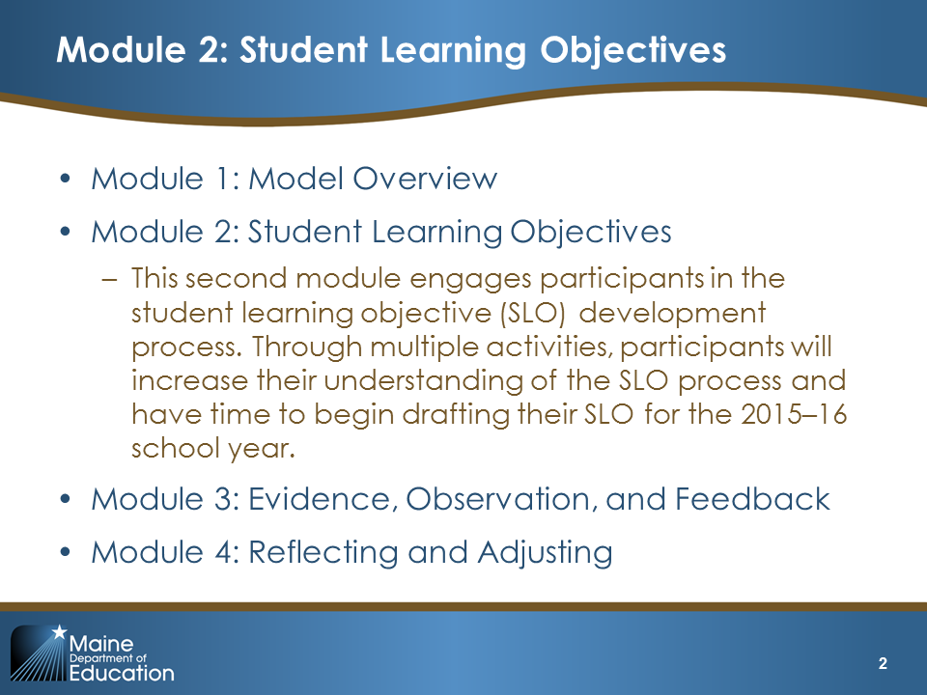  Slide 2
Note: This slide includes the agenda.  Explain:  “Here is the agenda for today’s session. We will begin with an activity intended to activate our prior knowledge and prepare us for learning. We will then walk through a series of activities designed to increase our understanding of SLOs. During these activities, you will think like an SLO writer, review a high-quality SLO, and provide feedback on a poorly written SLO. At the end of the session, you will have an opportunity to begin writing your SLO and then reflect on your learning during this module.” | 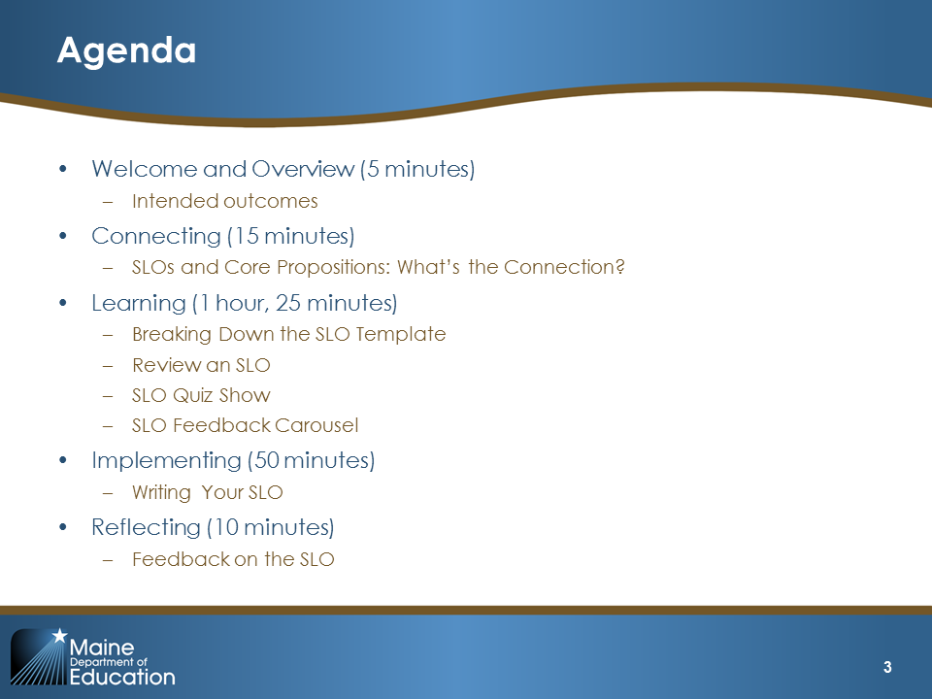  Slide 3
Explain:  “By the end of this session, you should understand the SLO process and your role in it, understand the Maine DOE guidance for developing an SLO, be able to use the SLO template checklist to review an SLO, and be able to draft an SLO that is specific to your content area.” | 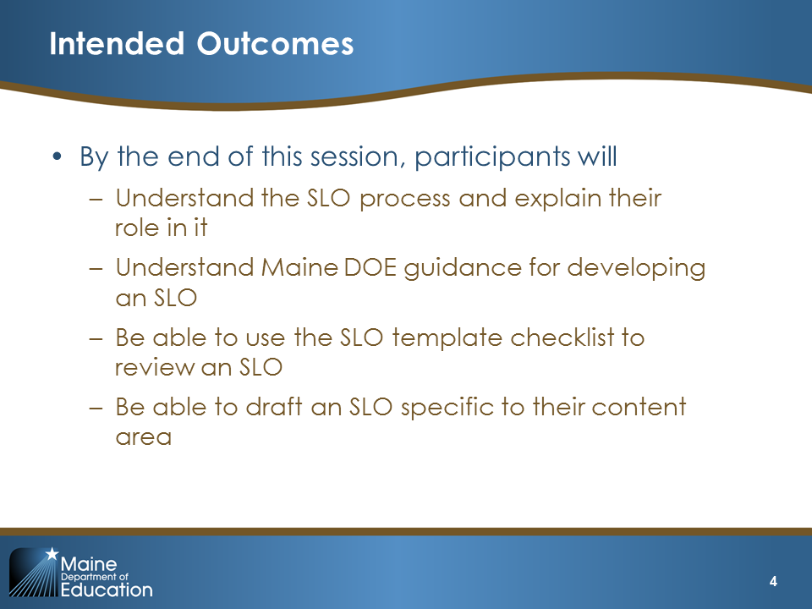  Slide 4

II. Connecting (20 minutes)

Connecting Content (5 minutes)

Purpose and Intended Outcome
- Introduces the basic idea of an SLO
Explain:  “As you will recall, the Maine DOE T-PEPG model calls for an ongoing series of conversations and activities that emphasize formative feedback and professional growth throughout a cycle of evaluation. Although the length of the cycle will be differentiated after the first summative rating for all teachers, the process can be illustrated in four steps. Individual teachers—in collaboration with Professional Cohorts consisting of grade-level and subject-area teams and administrators—take a leading role during each step of the process.  First, teachers set goals for their students’ growth. They use these student growth goals to inform their own professional growth goals.  Next, they gather evidence of practices that cannot be easily observed, adjust their practices in response to feedback, and work toward their goals. Throughout the cycle, teachers reflect and self-assess using the rubric.  Finally, they use the evaluation results to inform their professional growth, career opportunities, and the next evaluation cycle. Although SLOs are part of each step of the four-step evaluation cycle, today’s session focuses on writing SLOs, which is part of the expectations and goal-setting step. Later modules will focus on how SLOs fit within these other steps.” | 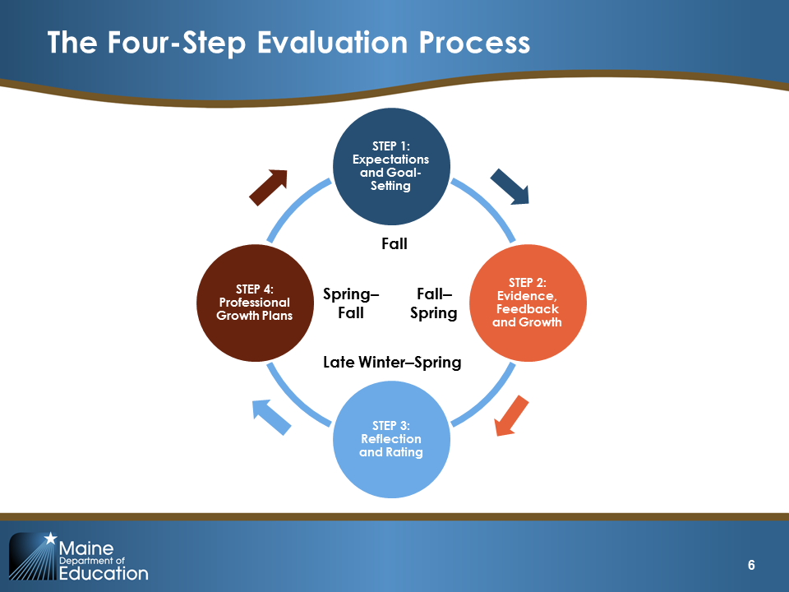  Slide 6
Explain:  “Before we dive into the content today, let’s set the stage by clarifying what we mean by a student learning objective—or SLO—in Maine.  Although SLOs are often thought of as having a single purpose—for example, identifying a specific learning target for students—they actually incorporate much more information. In Maine, an SLO refers to a ‘comprehensive process-framework for developing, articulating and recording measurable academic growth targets for students…’ The framework has five components:  - Teacher of record and instructional record  - Student demographics and baseline data  - Content standards  - Summative/postassessment  - Growth target  - Instructional plan  - Formative assessment processes  We’re going to work through each of these components in detail today.” | 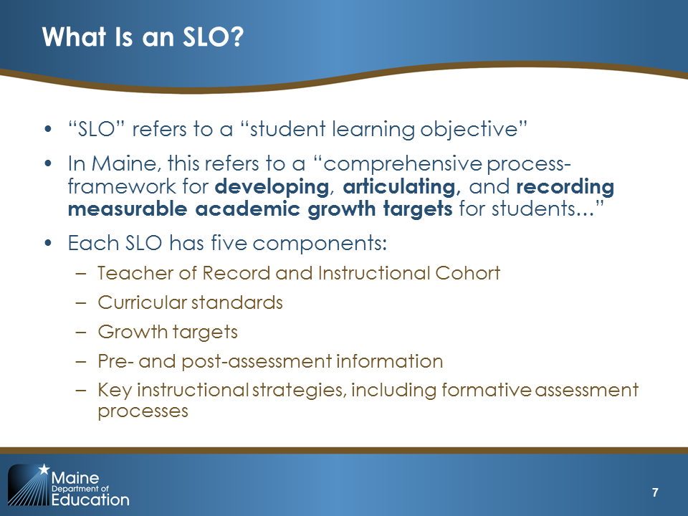  Slide 7
Explain:  “In this first year, you will need to write and complete one SLO. In year two, you will complete two SLOs. All three SLOs will count towards your summative effectiveness rating in June 2017. In year three, you will set a minimum of two SLOs annually. The exact number will vary depending on your professional growth plan.” | 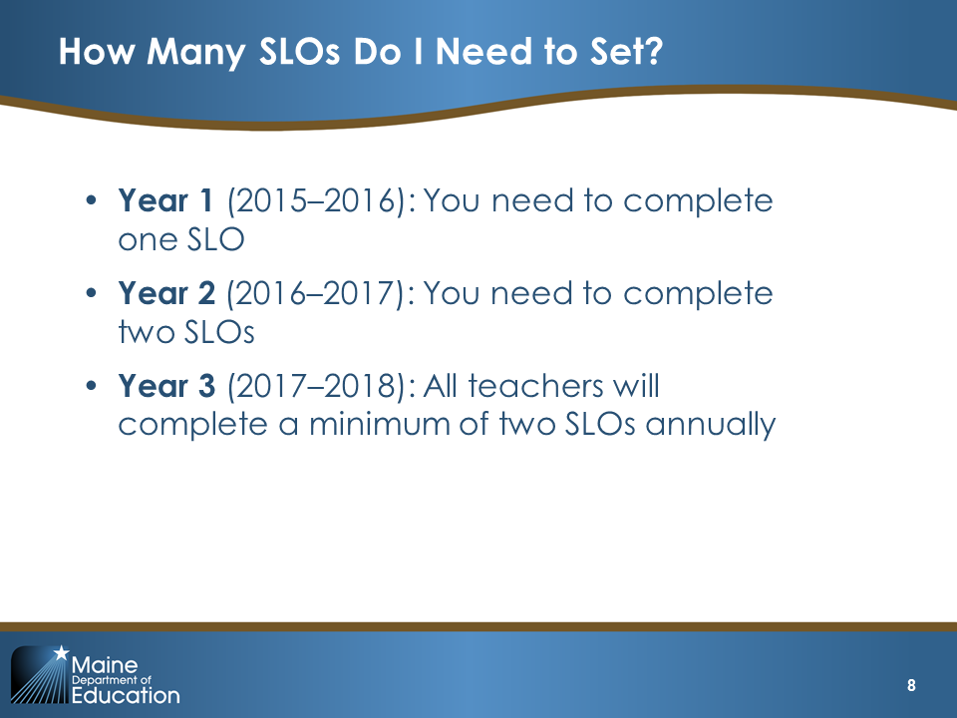  Slide 8
Facilitator’s Note: Districts may implement a different process than the one described below for SLO development and review (such as convening a designated review team). You may need to modify the slide and text below to reflect the approach implemented in your district.  Explain:  “To help ensure that SLOs are rigorous and comparable, Maine DOE has designed an SLO approval process that is built into the Professional Cohort framework. Within this Professional Cohort, you will learn to review and provide each other feedback on your SLOs through a calibration process. After you receive feedback from your peers, you will adjust your SLO and submit it to your cohort for preapproval. To preapprove an SLO, peers will complete a preapproval checklist. Preapproval means the professional cohort has examined the SLO against the checklist and confirmed it is ready for final, administrator approval. After preapproval, the SLO will be forwarded to the administrator (or his or her designee) for final approval.”  Note: Pass out Handout 1. SLO Approval Checklist | 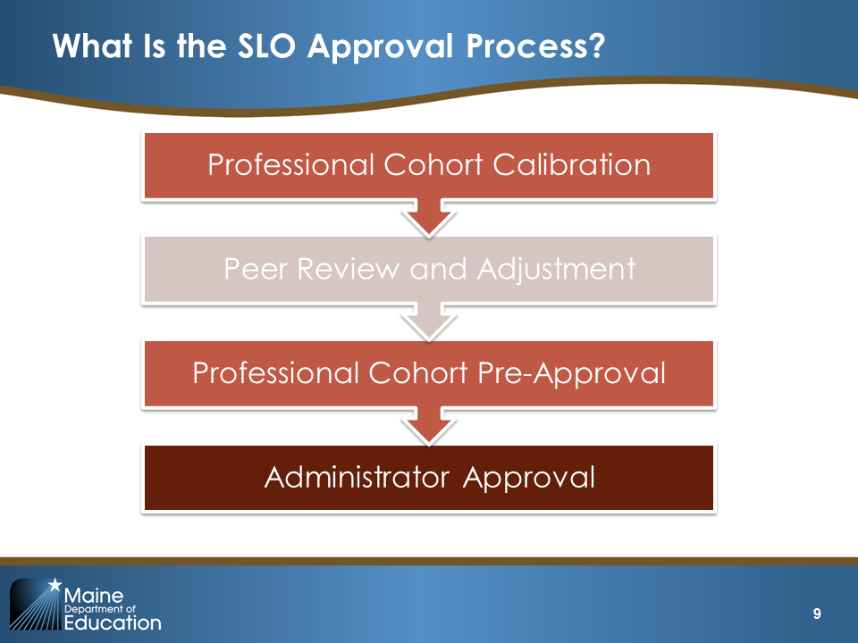  Slide 9
Explain: “The Maine DOE SLO Handbook currently features a Student Learning and Growth Scale that is based on the percentage of students who meet the growth target. For example, if 75 percent of students met their growth target, then the teacher’s rating would be ‘Moderate’.” | 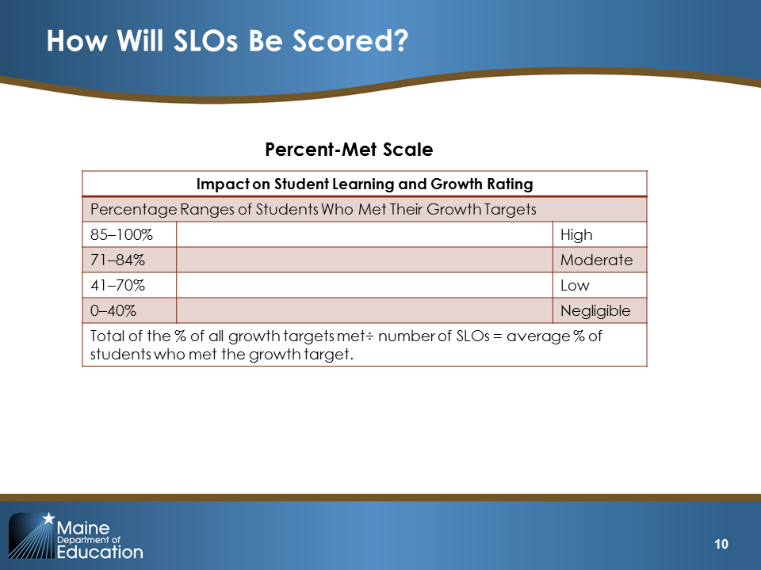  Slide 10
Explain: “However, through pilot-year conversations, some new thinking on rating growth targets has emerged, and with it an approach that seems to provide greater assurance of equity in teacher ratings than the ‘percent met’ approach. The Maine DOE will not be revising the SLO Handbook until the end of the pilot year, but this new approach will likely replace the Percent-Met Scale and districts are strongly encouraged to consider it. If adopted by a district, the Mean-Performance-gap Reduction scale will eliminate the necessity of setting growth targets.” | 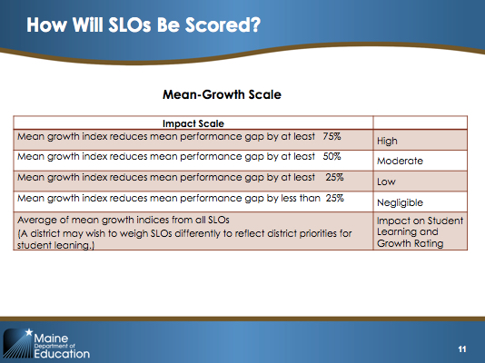  Slide 11

Connecting Activity (15 minutes)

Purpose and Intended Outcome
- Helps participants to connect the information from Module 1 on Core Propositions with their work on SLOs for Module 2
- Helps participants begin to understand how the SLO process reflects their daily practice
Explain:  “Too often, SLOs are viewed as a separate, additional process disconnected from other evaluation processes, and, even more worryingly, as separate from the daily practice of instruction and teaching. Maine DOE has adopted an SLO process because it brings the primary responsibilities of the teacher into focus and alignment. Effective teachers know their students’ learning needs, set rigorous and feasible learning targets, align practice and instruction with the achievement of those targets, and monitor student progress through high-quality assessments.  To explore this connection between the SLO process and teacher practice, let’s take a few minutes to consider how the Core Propositions and SLO process are aligned. At your table, use the Companion Guide and identify which Core Propositions and standard indicators are connected with the SLO process. Take between five and seven minutes to have this discussion and then we will share out.” | 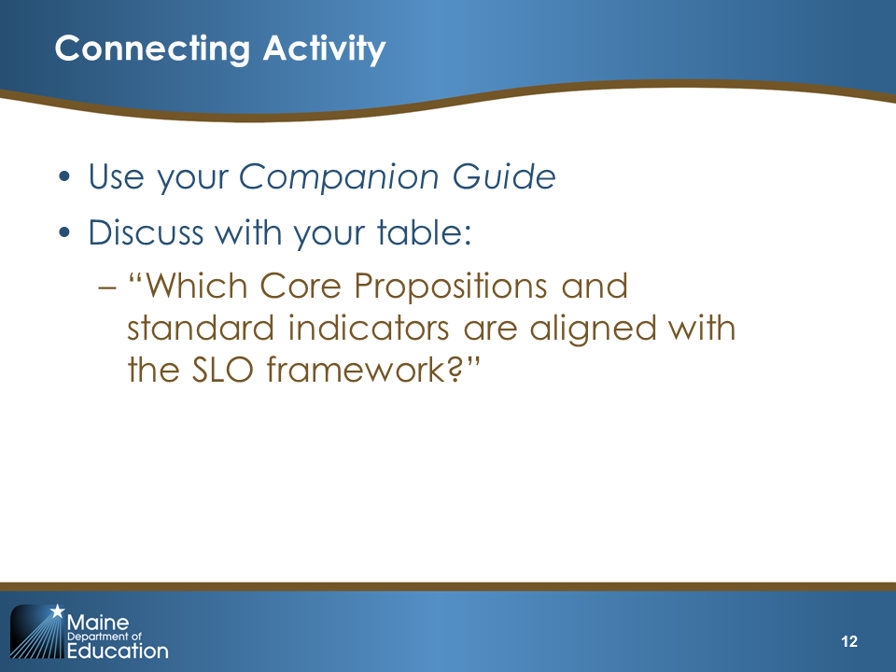  Slide 12
After five minutes, encourage groups to wrap up. Ask for volunteers to share out their answers. Check off which Core Propositions and standard indicators are mentioned from the list that follows. If any have been missed, use the appropriate text and slide (from Slides 13–15) to cover that material with participants.  Core Proposition and Standard Indicator List:  - 1.1 Understanding of students  - 1.2 Application of learning theory  - 2.1 Subject knowledge  - 2.2 Pedagogical content knowledge  - 2.3 Goal-focused planning  - 3.3 Assessment of student progress  - 4.1 Reflective practice  - 5.1 Professional collaboration  If needed, explain:  “As you will see in this and the following slides, SLOs align with all five Core Propositions. As part of the SLO process, teachers demonstrate that they are committed to students and their learning by analyzing data to identify student strengths and opportunities for growth. In addition, teachers provide information about how they will implement instructional strategies based upon their knowledge of students and how students learn.” | 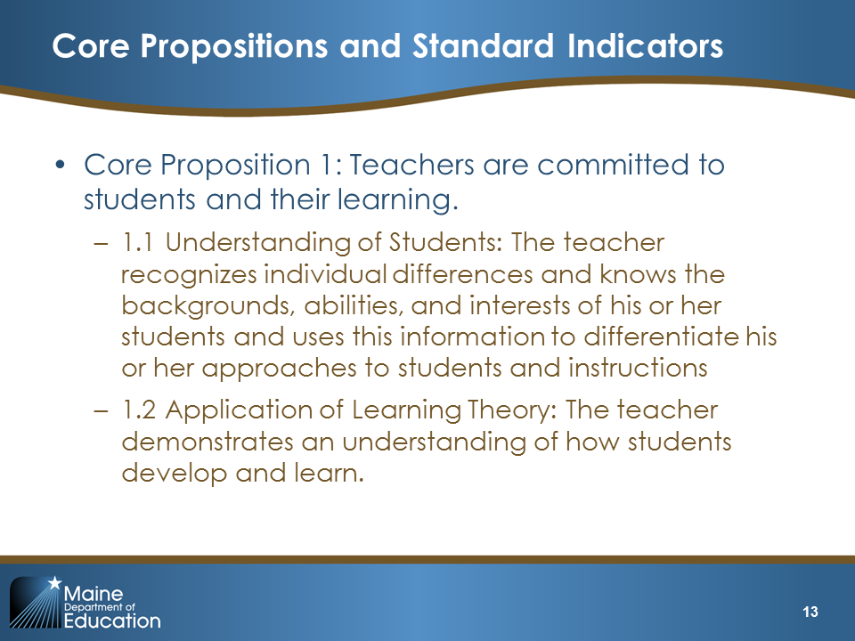  Slide 13
If needed, explain:  “During the SLO process, teachers display their subject knowledge and pedagogical content knowledge in charting the content standards, curriculum, and learning experiences necessary for helping students reach their growth targets. They take responsibility for managing and monitoring student learning.” | 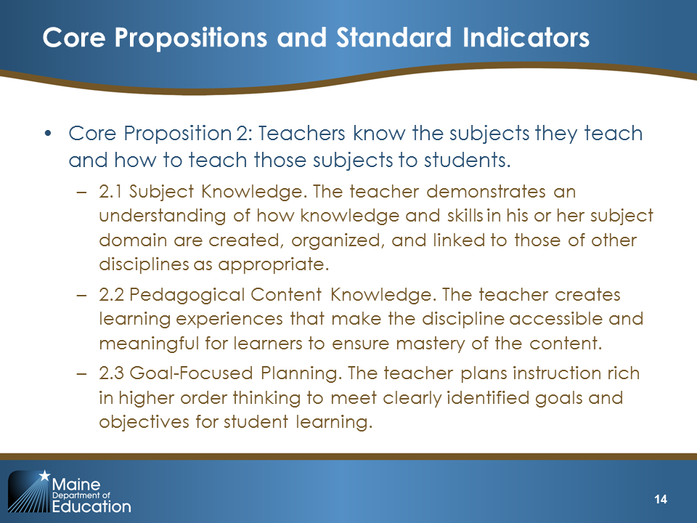  Slide 14
If needed, explain:  “They set goals for students and then monitor student progress toward those goals through formative assessments. Throughout the year, teachers reflect on their practice and modify their approaches to ensure that all students are making sufficient progress throughout the year. Teachers also reflect on their performance at the end of the year during the SLO scoring conversation. The SLO process can also encourage teachers to think systematically about their practices. Teachers are strongly encouraged to collaborate during the SLO writing process and to create SLOs that align with school goals, initiatives, and priorities.” | 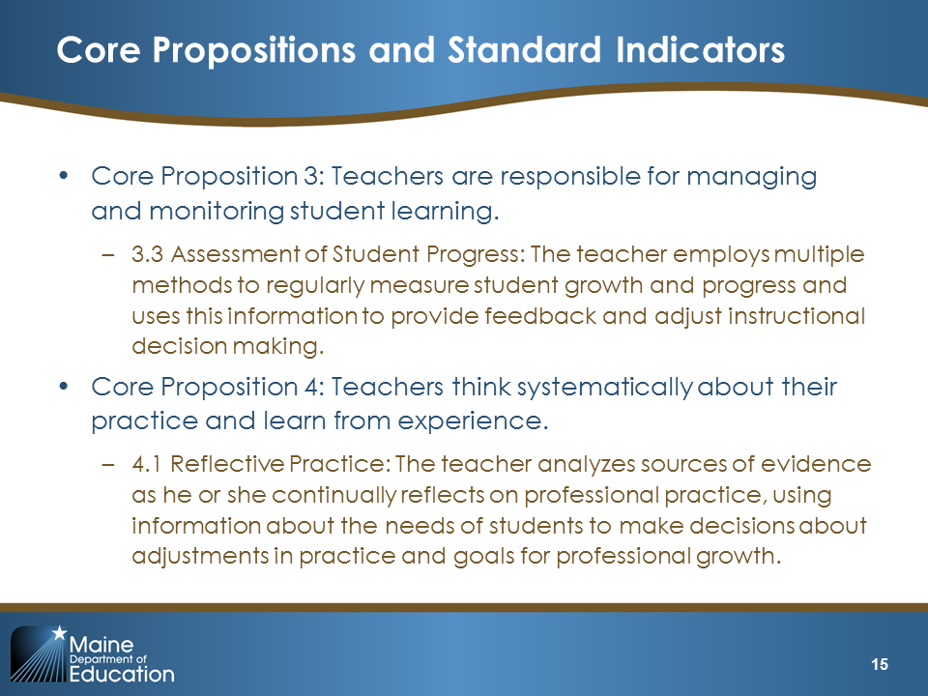  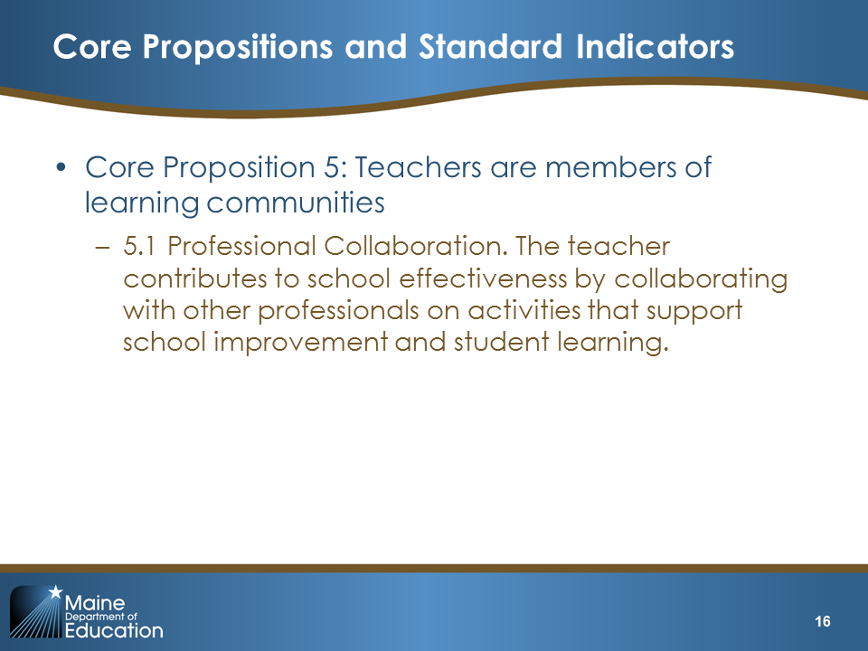  Slides 15 and 16

III. Learning (1 hour, 25 minutes)
Slide 17 is the title slide for the “Learning” section. | 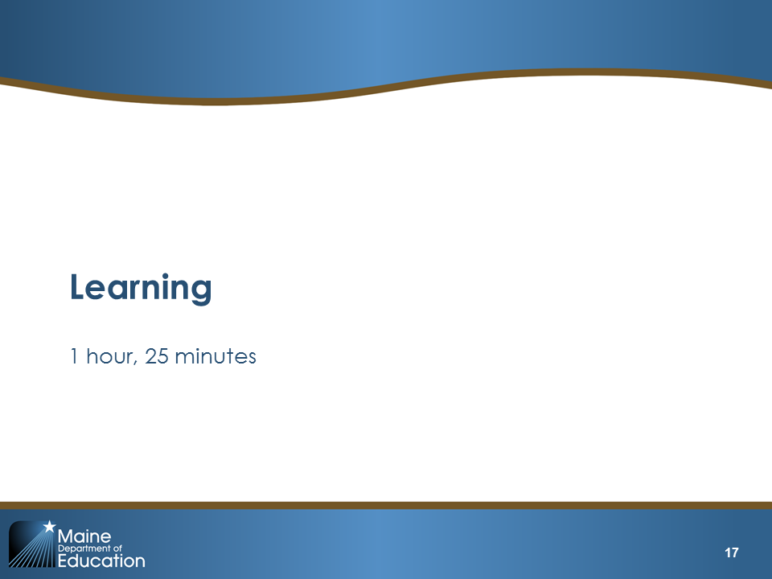  Slide 17
Learning Content 1 (5 minutes)  This slide features the SLO Process graphic.  Explain:  “Now we are going to learn more about SLOs and we are going to begin to unpack the SLO process.  When we think about SLO implementation, we can think of it as an ongoing cycle. First, the teacher prepares to write the SLO by examining baseline data and considering her or his knowledge of students. Next, the teacher collaborates with colleagues through the Professional Cohort to write an SLO. Once the teacher develops the SLO and has it preapproved by the Professional Cohort, the SLO is submitted to the administrator for approval.  One or more district-determined designees will review the SLO for quality. Although the SLO has been preapproved, the approval designees will return the SLO to the teacher for revisions and resubmittal if any further improvement is needed.  Once the SLO has been approved, the teacher continues to deliver instruction and monitor student progress. Based on formative assessments, the teacher adjusts his or her approach and/or employs interventions to ensure that all students are making progress. This step in the process can also include a formal or informal midcourse conversation within the Professional Cohort, or between the teacher and administrator, to discuss student progress up to that point, as well as any modifications that the SLO requires based on special circumstances.  At the end of the course or year, the teacher meets with a district-designated administrator or administrator team to review data and determine whether students met their growth targets. From this information, the administrator or administrator team assigns an SLO score. The purpose of the meeting with the administrator or administrative team (beyond calculating the SLO rating) is to have a meaningful conversation about student progress. With their administrator or administrator team, the teacher identifies strengths or weaknesses in student progress. The teacher and administrator should use the SLO results to inform professional development and SLO development for the following year.”  Note: For the last line below, click to make the orange circle appear and move through the steps.  “Today we will focus mainly on the first three steps of the SLO process, developing the SLO, and approving the SLO, which you see here circled in orange.”  Transition to Slide 18  Explain:  “This next activity will help us begin to think like SLO writers.” | 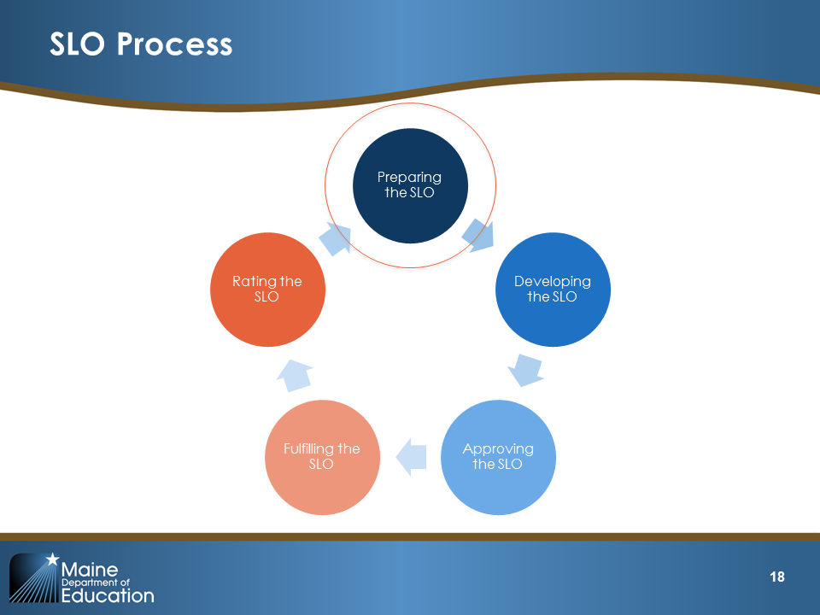  Slide 18

Learning Activity 1 (15 minutes): Breaking Down the SLO

Purpose and Intended Outcomes
- Begin thinking like an SLO writer
- Become familiar with the SLO template and SLO Approval Checklist
Explain the following instructions for Part 1:  - Take eight index cards and number the cards.  - Listen to my prompts and record your answers. Use a separate index card for each prompt.  - After completing the cards, you will review the SLO template.  - You will then organize your cards to match the SLO template.  Read the following prompts, waiting between prompts to make sure participants have enough time to write their answers.  - “Think about one of your courses or classes. What are some areas in which students are particularly strong? What are some areas in which they need to improve? Write this information on Card 1.”  - “How do you know that students need to improve in this area? Write this information on Card 2.”  - “Now be a little more specific. On Card 3, write down the content or skills in which your students need to improve.”  - “Thinking about those areas of weakness you identified, what do you want your students to be able to do by the end of the course that is related to those skills or content pieces? Write that on Card 4.”  - “What instruction might you provide to help students reach the goals that you identified on Card 4? Write down some instructional strategies on Card 5.”  - “On Card 6, write down how you might monitor student progress throughout the year. This could be a quiz or a test, or daily practices around questioning, observing students in groups, exits slips, or one-on-one conversations.”  - “On Card 7, identify how you could assess whether students did or did not meet the expectations you identified on Card 4.”  - “Finally, write the length of your course on  Card 8.”  Have participants reorganize their cards to mirror the SLO template (Handout 2). The answers are as follows:  - Interval of instruction: Card 8  - Student demographics and baseline data (template item 8): Cards 1 and 2  - Content standards (template item 9): Card 3  - Summative assessment (template item 10): Card 7  - Growth targets (template item 11): Card 4  - Instructional plan (template item 12): Card 5  - Formative assessment process (template item 13): Card 6 | 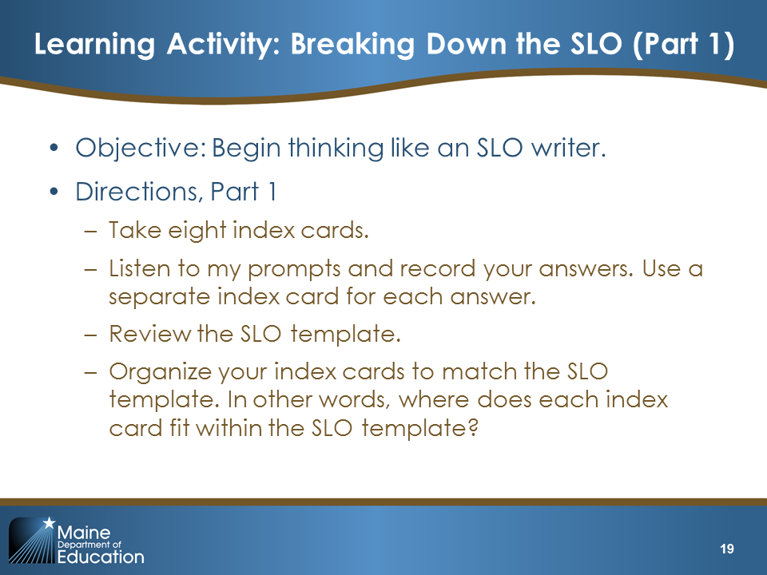  Slide 19
Explain:  “Next, take out the SLO Approval Checklist (on page 28 of the SLO Handbook). Review what you have written on your cards against the checklist. Check off any item on the list that your cards cover.”  Note: The goal of this part of the activity is to have participants see that, even in a few minutes, they were able to complete parts of the SLO. Most likely, participants will be able to check off boxes related to student needs, content standards, summative assessment, instructional strategies, and formative assessment  “Ask participants to share out a few of the areas that they checked off.  Now that you have a more detailed understanding of the content of an SLO, in what ways does the SLO reflect the way you already think about your students and their learning?”  Give participants two to four minutes to talk as a whole group about this question and facilitate their sharing with each other. | 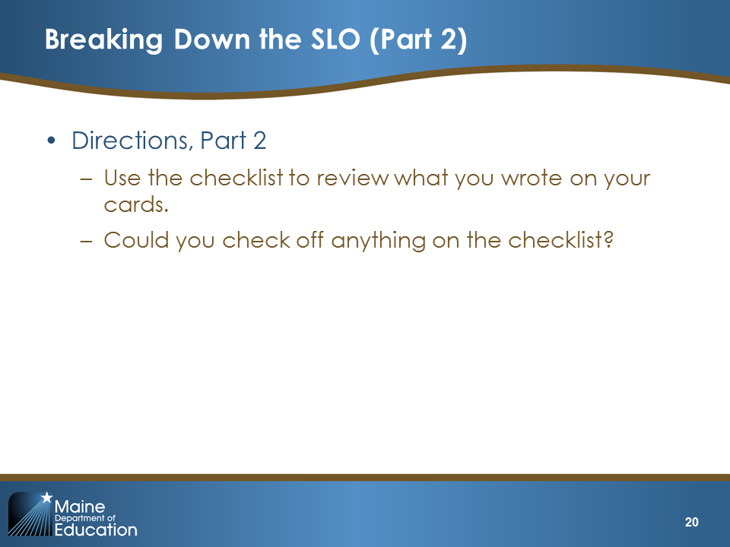  Slide 20
Possible Facilitation Challenges and Solutions
Challenge | Solution(s)
Participants do not think the activity is useful. | Explain that this will help them make the connections between how they already think as teachers and how they will write SLOs.
Participants do not feel they know enough about their students to provide answers. | Assure participants that this is just an activity and that they will not be penalized for not providing fully detailed and complete answers. Also, remind participants that prior experience with similar student groups can be a basis for determining needs.

Learning Wrap-Up/Debrief (5 minutes)
Explain:  “Which components of the SLO template seem the most straightforward? Which components will require the most thought and learning?”  Give participants two to four minutes to talk as a whole group about this question and facilitate their sharing with each other. Take note of where participants say they will need the most support and use this information in your Professional Cohort planning.  Tell participants that the next activity will provide them with an opportunity to see what each component looks like in a sample SLO. | 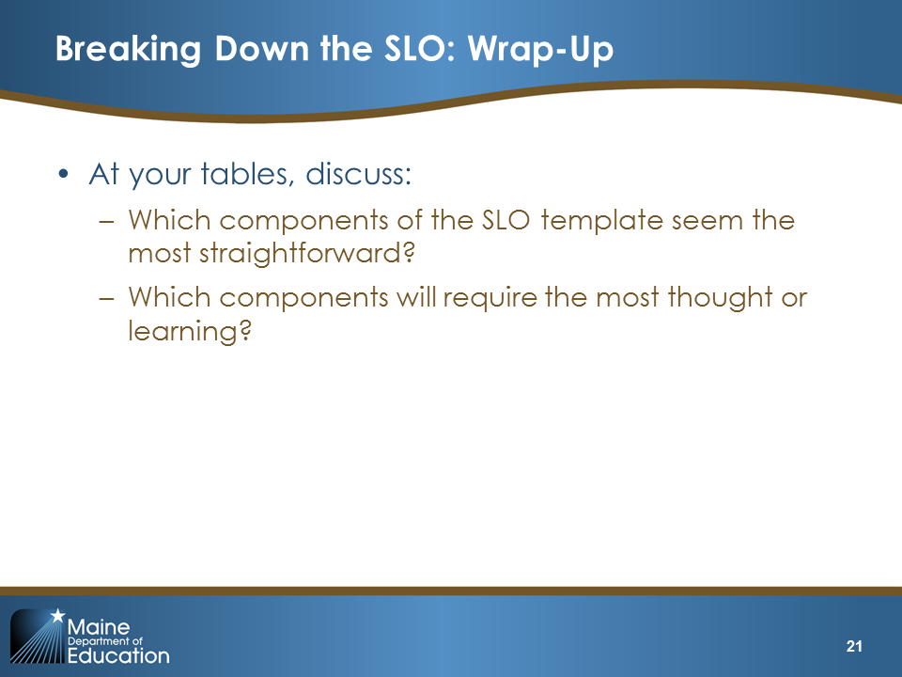  Slide 21

Learning Activity 2: Review a Complete SLO (15 minutes)

Purpose and Intended Outcomes
- Increase understanding of what a completed SLO looks like
- Generate questions about the components of the SLO

Activity Detail
Explain:  “This activity will give you an opportunity to increase your understanding of what a complete SLO looks like.  Our objectives for this activity are to:  - Increase understanding of what a completed SLO looks like  - Generate questions about components of the SLO  In pairs, review the sample SLO in Handout 3 with the SLO Approval Checklist.  As you read, identify where in the text the SLO meets each criterion in the SLO Approval Checklist.  Jot down any questions you have about the SLO components on sticky notes.” | 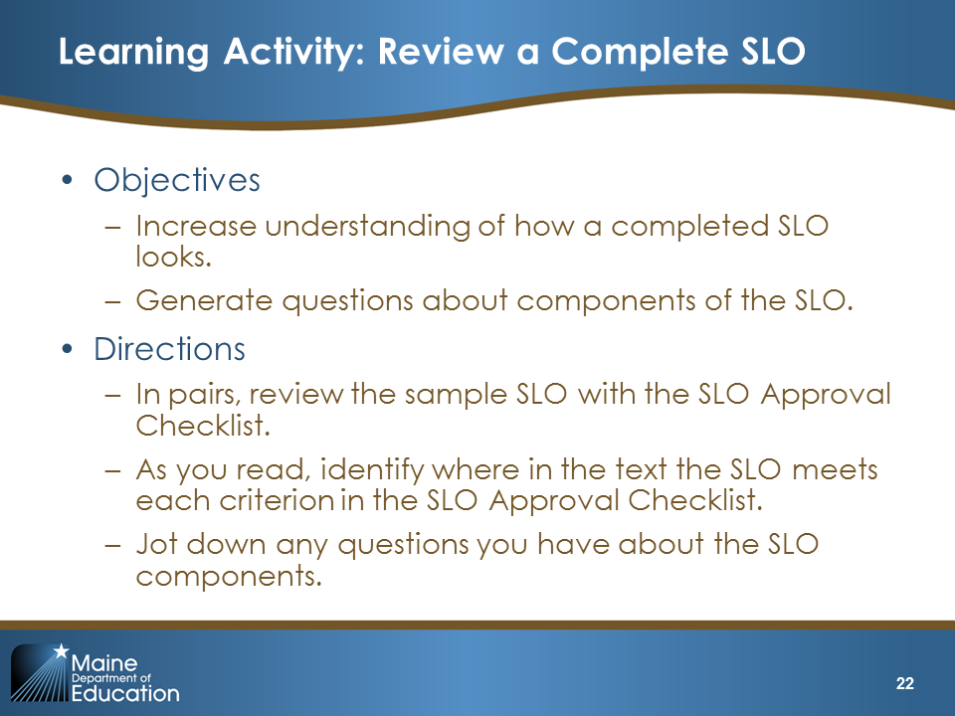  Slide 22
Possible Facilitation Challenges and Solutions
Challenge | Solution(s)
Participants object to reading an example that is not in their subject area. | Explain that this SLO provides a starting point. It is more important in this activity to observe the level of detail in the SLO and the type of information that is included rather than the subject-specific information. In addition, the reviewers’ notes were developed as instructional pieces to aid both teachers and reviewers. Remind participants to pay very close attention to the reviewer’s notes.

Guiding Questions
- What types of information are included in the SLO?
- How would you describe the level of detail in an SLO?
- What concepts or pedagogy do the reviewers’ comments reveal?
- What key pieces of information should be included in each component?
- In reading this, what additional questions do you have about the components of the SLO?

Learning Wrap-Up/Debrief 2
Explain:  “Take a moment now to think of any questions you still have about SLOs. Write the questions on sticky notes, if you have not done so already. Bring up your sticky notes and post them on the wall. (Direct participants to the wall you would like them to use for this exercise).”  Review the questions as people are posting them to get a sense of where participants feel there are gaps in information. Answer the questions that seem most pressing and then tell others that you would be happy to help them locate answers to their questions later if they are not answered in this module. | 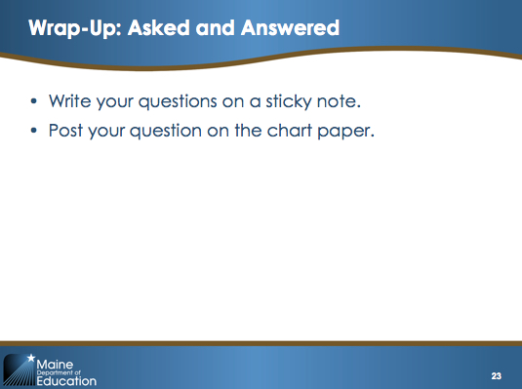  Slide 23

Learning Activity 3: SLO Quiz Show (15 minutes)

Purpose and Intended Outcomes
- Understand Maine DOE’s guidance around SLOs
- Develop familiarity with Tables 1–12 in the SLO Framework Handbook
Divide participants into teams by table or into groups of five or six people (adjust based on the total number people). Give each team a “noise maker” or small flag (e.g., bells, musical instrument, buzzer). If you wish, you can pass out candy or small door prizes for correct answers or for the team that gets the most correct answers to create more of a “game” atmosphere.  After sorting participants into teams, continue with the text below.  Explain:  “Does everyone have their SLO Handbook? Go ahead and briefly look through Tables 1–12 on pages 11 through 27. You can use the information in these tables to help answer the questions in the quiz show. As soon as your table/group has agreed on an answer, ring in. The first team to do so and give the correct answer wins the point. In Handout 4, you can jot down which table/group has the correct answer and any related information, as well as any notes or additional questions you may have.” | 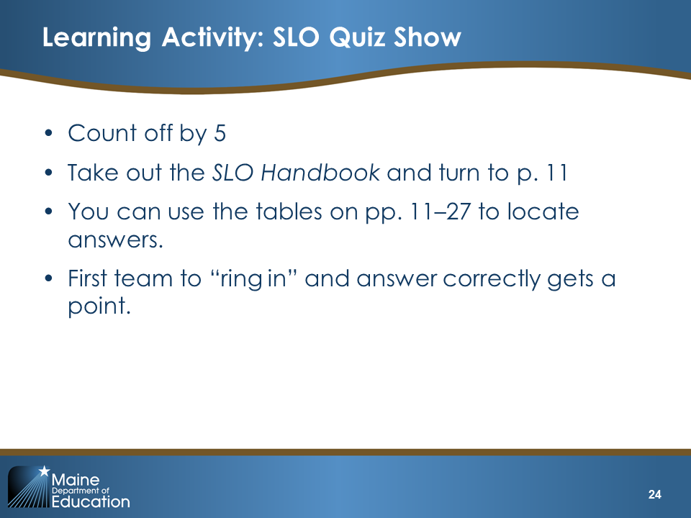  Slide 24
Read the question on the slide. After a team rings in with the correct answer, ask them to explain why they chose that answer and ensure all participants understand the correct answer. If they correctly answer an “I need more information” question, ask them “What is the information you need?” Sample explanations for each answer are provided for each slide but try to elicit or build off participants’ own explanations rather than simply reading the answers.  Q1. Answer: No  Explain:  “SLOs usually set an academic goal for a group of students, whereas an IEP is focused on an individual student.  How should Mrs. Green have set growth targets for her students with IEPs?  Her SLO growth target should align with the students’ IEPs but should not replicate or duplicate the IEP goals themselves.” | 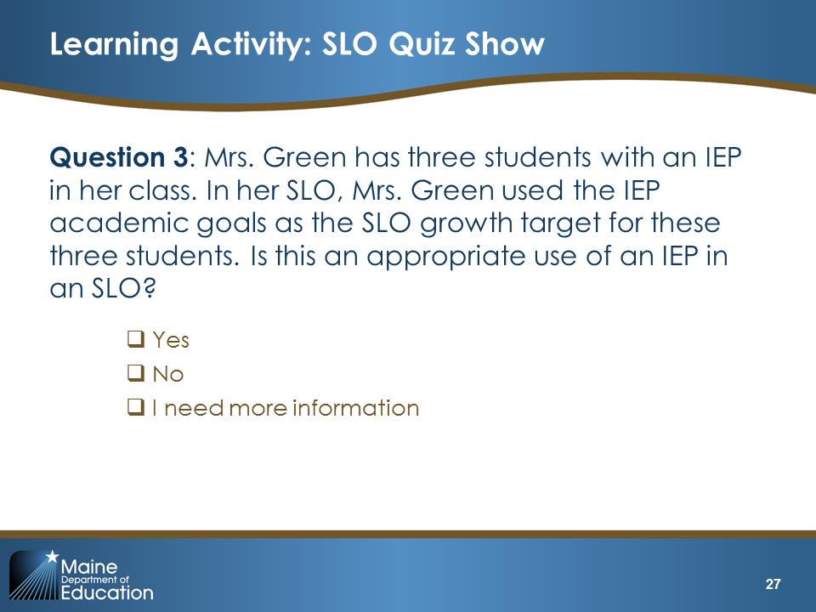Slide 25
Q2 Answer: I need more information  Explain:  “Mr. Warren teaches three classes in two different schools. How many students does he teach in total? It’s possible that he may teach several hundred students, or if it’s a small district, perhaps he only teaches 30 or 40 students in total. Table 1 notes that “very large student assignments (such as those belonging to an itinerant teacher) warrant the identification of a smaller group of students comparable to a regular class size in the district.” In Mr. Warren’s case, we need to know how many students he teaches in total. The key take-away here is that, when appropriate, your SLO should have an instructional cohort that includes all students assigned to a teacher or teachers in a particular class or learning experience.” | 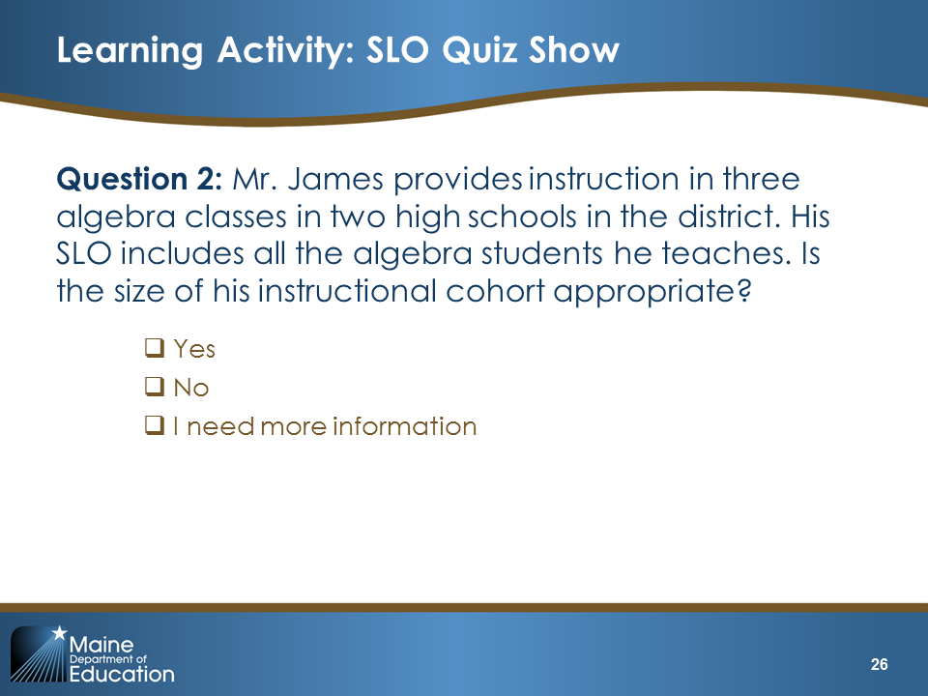  Slide 26
Q3 Answer: Need more information  Explain:  “The student does not immediately meet the criteria to be included because although she took both the pretest and the posttest, she did not attend the class at least 80 percent of the time. However, the teacher will need to consider whether the student can make up the missed class time or whether it can be addressed through online assistance. Note the language in Table 1 and note specifically the term ‘learning experience.’ What might this look like for a student whose attendance is close to the threshold?” | 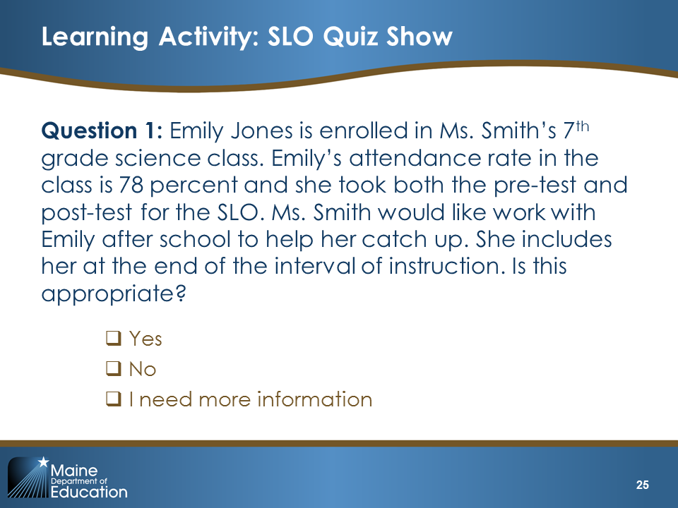Slide 27
Q4. Answer: No  Explain:  “The pre-assessment data suggest that there is a wide range of readiness for meeting the growth target. The growth targets should be differentiated to reflect this range, and Mr. Thomas may want to consider differentiating the summative assessment as well.”  Note to Facilitator: depending on which approach to SLO scoring your district has taken, you may need to modify the questions on growth targets to reflect the right information. | 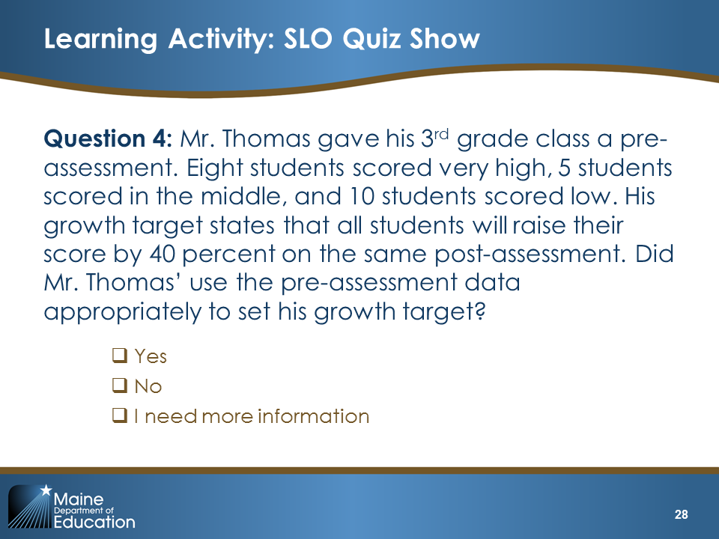  Slide 28
Q5. Answer: I need more information  Explain:  “The SLO guidance says the interval of instruction ‘must be long enough to accommodate substantive learning standards and growth goals and should be in place for the majority of the teacher’s annual assignment.’ What do you need to know to decide if the 30-day interval of instruction identified by Ms. Swan is appropriate?  You would want to know what learning standards the SLO covers and what the growth targets are. Is the interval she identified appropriate given what students are expected to learn?” | 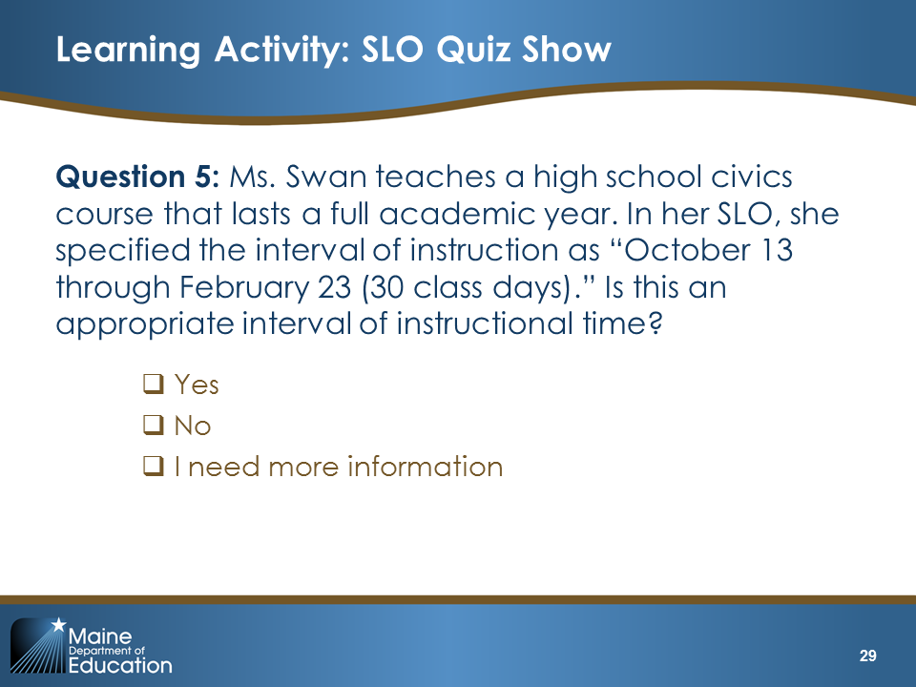  Slide 29
Q6. Answer: I need more information  Explain:  “This assessment is new and it is one that Ms. Norwood designed herself. We need to know how it was designed. In order to improve confidence and commonality, it should be developed collaboratively by educators who have expertise in the learning standards the assessment measures and, ideally, will use the assessment in similar contexts. We would also want to know what the content standards are in order to determine if the assessment can assess that content.” | 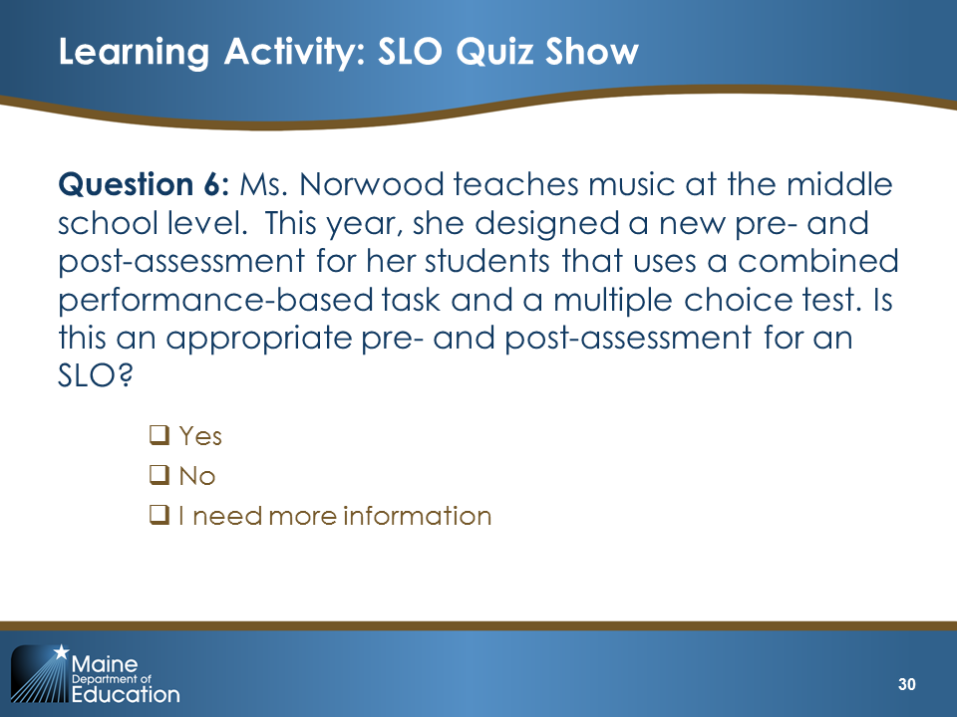  Slide 30
Q7. Answer: I need more information  Explain:  “What do you need to know in order to approve or recommend a revision?  - Do the targets align with school and district goals?  - Are the targets both ambitious and feasible?  - Are the targets the result of careful consideration of data, content, and assessments?  For example, does it make sense to lump all students who scored 50 percent or higher into a single category? Is a student who scored 55 percent the same as a student who scored 75 percent? Did any students score above 75 percent, and if so, can they demonstrate appropriate growth on the same assessment or is an additional/different assessment (such as a capstone project or extended performance task) needed to avoid a ceiling effect?” | 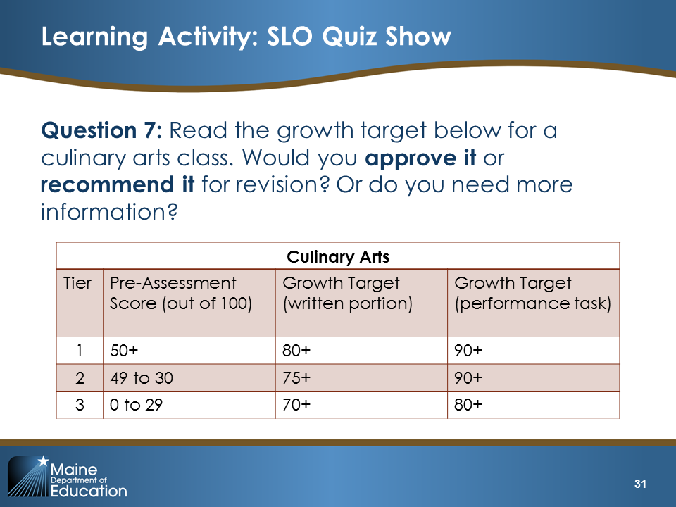  Slide 31
Q8. Answer: No  Explain:  “When describing her selection of formative assessments, Ms. Thomas should address how she might adjust instruction or intervention strategies for individual students, especially those who are struggling with the content. In this case, you would want to see a description of how Ms. Thompson plans to adjust instruction for her students with dyslexia and those significantly behind their grade level in reading.” | 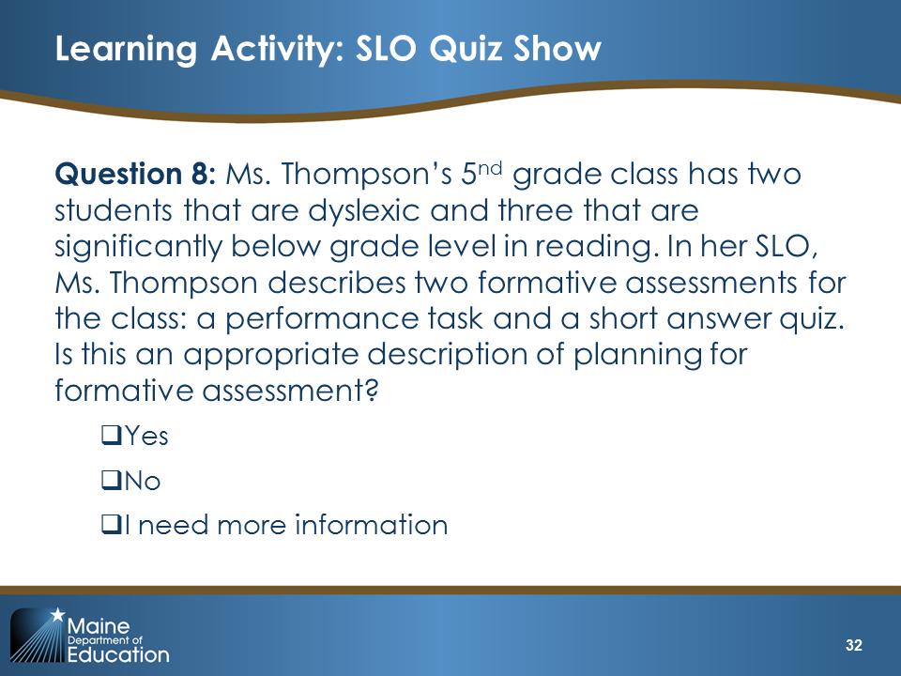  Slide 32
Q9. Answer: Not enough information  Explain:  “Snow days are one acceptable reason for modifying an SLO. However, what do you need to know in order to decide if Mr. Lewis’ modification is appropriate?  You would want to know if the days that the students missed affected instruction and activities related to the standards and content covered by the SLO. If yes, Mr. Lewis would need to explain and provide evidence of this to his administrator or administrative team, who would then determine whether to accept the modification.” | 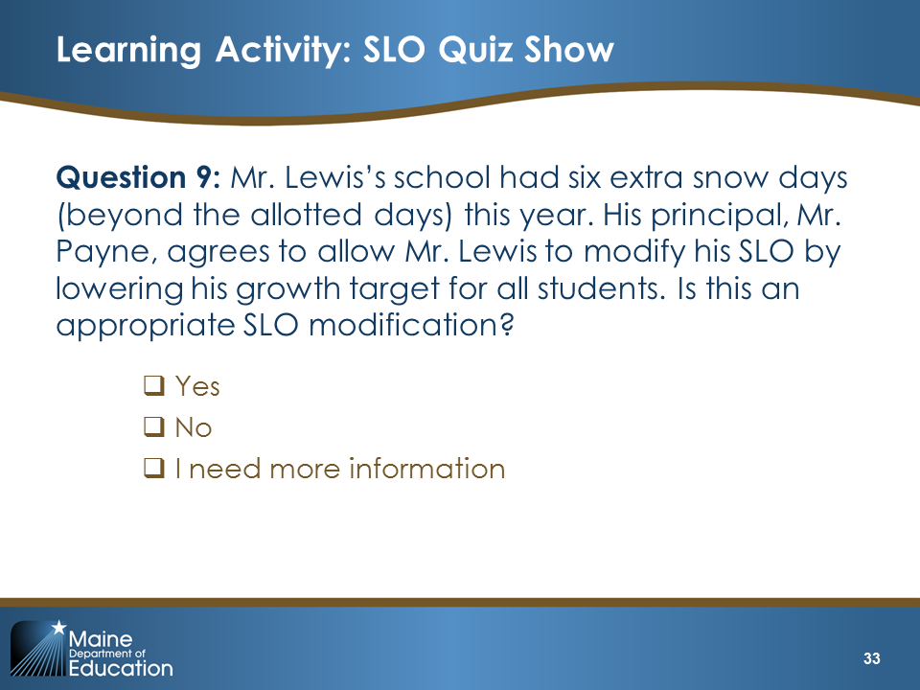  Slide 33
Q10. Answer: No  Explain:  “Shortening the interval of instruction to finish in December would also require changes to the standards covered, the formative assessment, the post-assessment, and the growth targets. In addition, shortening to only four months fails to account for Mrs. Jones’ instructional efforts in February and March.  What would be a more appropriate modification and what evidence would Mrs. Jones need to supply to support it?  For example, Mrs. Jones may feel that upon returning in February, formative assessment data suggest that the students are not on track to meet the targets due to her absence. Mrs. Jones could submit a modified SLO that proposes adjustments to the instructional strategies and growth targets that account for the lost time, while also making strong instructional choices to help accelerate students’ learning and allow them to catch up as much as is feasible.” | 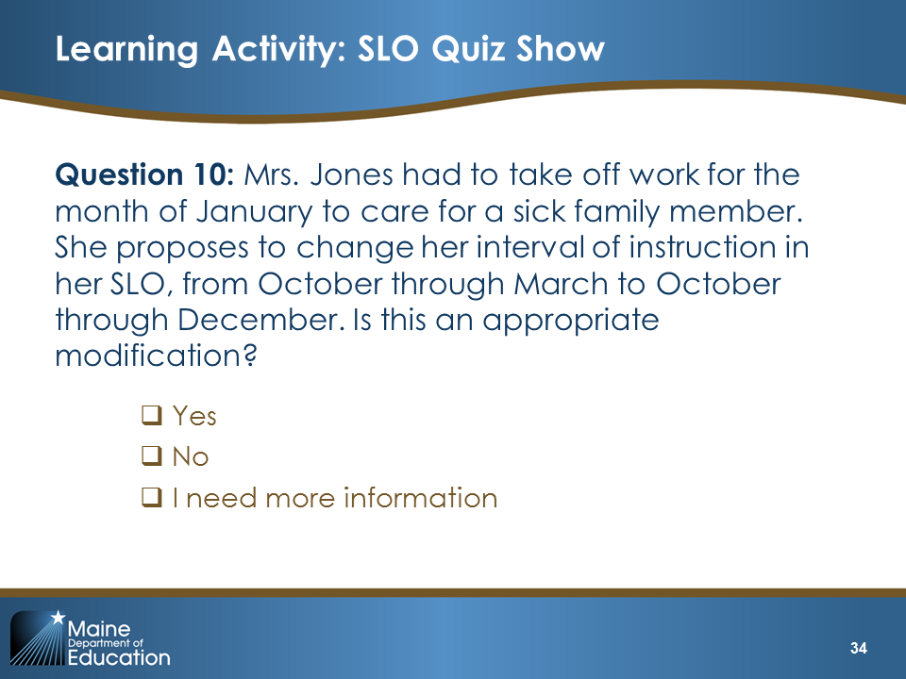  Slide 34
Q11. Answer: No  Explain:  “Ms. Miller did not engage her peers in reflecting on the formative assessment data and her instructional adjustments. Table 11 explains that teachers ‘should confer with peers periodically to assess progress and discuss possible approaches if students are struggling to reach learning targets. One way to do this is through the mid-SLO review we will complete in our Professional Cohort.”  The facilitator may wish to add information here on when that will occur and what teachers will be expected to prepare. | 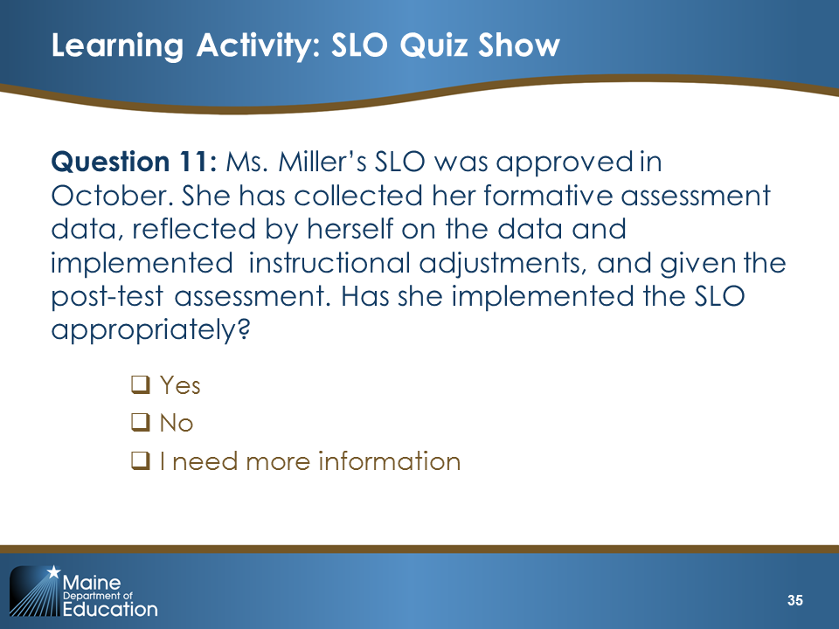  Slide 35
Q12. Answer: False  Explain:  “Before rating the SLO, teachers will meet with their administrator or administrative team, review the collected evidence, and have a meaningful conversation about student progress. In preparation for this meeting, Mr. Kowalski should use the students’ raw scores to determine the percentage of students who met the learning target (if the Percent-Met Scale is used) or the mean growth achieved by students (if the Mean Growth Scale is used). Ideally, this information should be presented in a table that provides individual-level data for the students, including pre-assessment scores, the mean growth target (if applicable), the summative score, and (if the Percent-Met Scale is used) a statement of whether Mr. Kowalski met the target not.” | 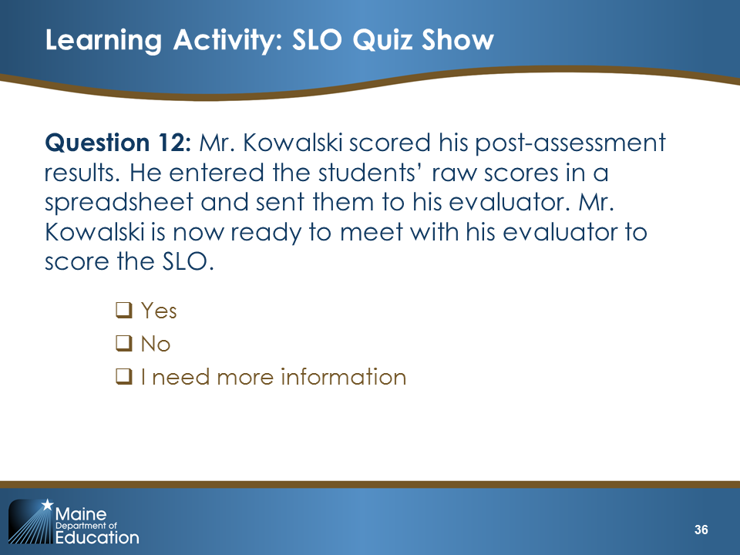  Slide 36

Learning Activity 3: Feedback Carousel (35 minutes)

Purpose and Intended Outcomes
- Increase familiarity with the SLO Approval Checklist
- Practice providing feedback to a peer

Facilitation Notes
- Prepare chart paper in advance by writing the following on a piece of chart paper:
- Boxes 1–7
- Box 8: Student Demographics and Baseline Data
- Box 9: Content Standards
- Box 10: Summative/Post-Assessment
- Box 11: Growth Target
- Box 12: Instructional Plan
- Box 13: Formative Assessment Process
- Give participants 15 minutes to review the SLO in Handout 5. Make sure everyone has a sheet of red, green, and yellow dots.
- Make sure that the chart paper is posted in a place where people can easily move from chart paper to chart paper. A hallway is a good option, but we recommend posting the charts on one side of the hall only so people can use the other side to move around.
- Once people are in their groups and at the chart paper, you are in charge of keeping track of time. We recommend providing participants four to five minutes at each station.
- After the activity is complete, pass out the Handout 6A or 6B: Annotated SLO.

Activity Detail
Explain:  “Some people learn more from seeing a high-quality example. Others learn more from seeing a low-quality example and determining how it could be improved. This next activity will give you the opportunity to think critically about an SLO and determine how you would improve it.”  Read the directions on the slide. | 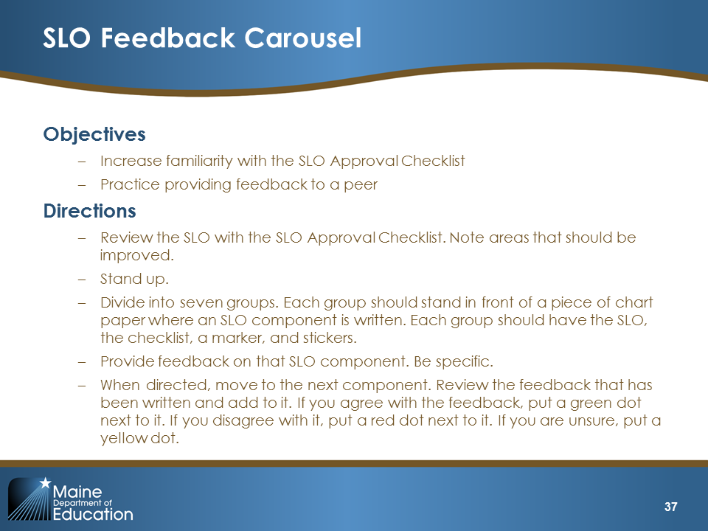  Slide 37

Possible Facilitation Challenges and Solutions
Challenge | Solution(s)
The activity seems to be taking too much time. | Adjust the activity if needed so that participants only visit four or six components. This configuration is not ideal but it will still provide participants and opportunity to see specific feedback.

Guiding Questions
- What types of information are included in the SLO?
- How would you describe the level of detail in the SLO?
- What key pieces of information should be included in each component?
- Having read this SLO, what additional questions do you have about the components of the SLO?

Learning Wrap-Up/Debrief 3
As a facilitator, you can debrief this activity in one of two ways. If participants frequently disagreed with or were unsure about the feedback, debrief as a whole group, talk about the pieces of feedback that prompted disagreement, and try to come to some consensus.  If participants seemed to agree, have participants complete the 2-1-2 on Slide 38. Have participants list two things they learned about SLOs from this activity, one piece of feedback they will remember when they are writing their own SLO, and two questions they still have about SLOs. | 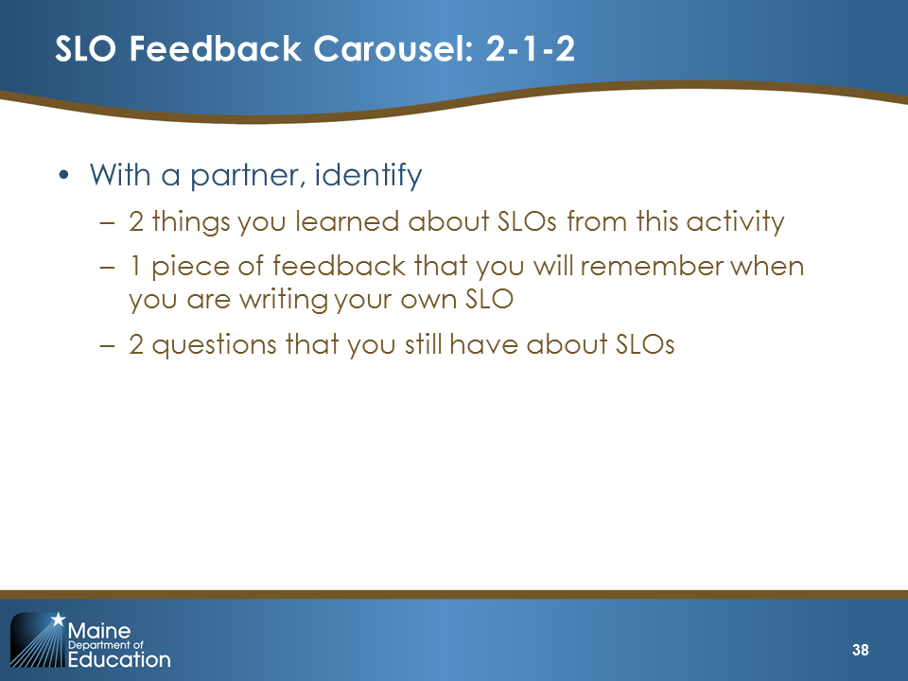  Slide 38

Possible Facilitation Challenges and Solutions
Challenge | Solution(s)
There is not enough time for participants to share out during the wrap-up. | Walk around the room as people are talking and take note of what you are hearing. Instead of calling on individual people, report to the group what you heard being discussed.

IV. Implementing (50 minutes)

Implementing Content (5 minutes)
Slide 39 is the title slide for the “Implementing” section.
Explain:  “Now that you have learned about SLOs, you will have the opportunity to begin writing your own SLO. You can use Handout 7 to begin this process.”  Review the key considerations on Slide 40 and alter the date in the last bullet to reflect your district’s calendar. You may want to provide Handout 7 in electronic form so that teachers can type directly in the SLO template. | 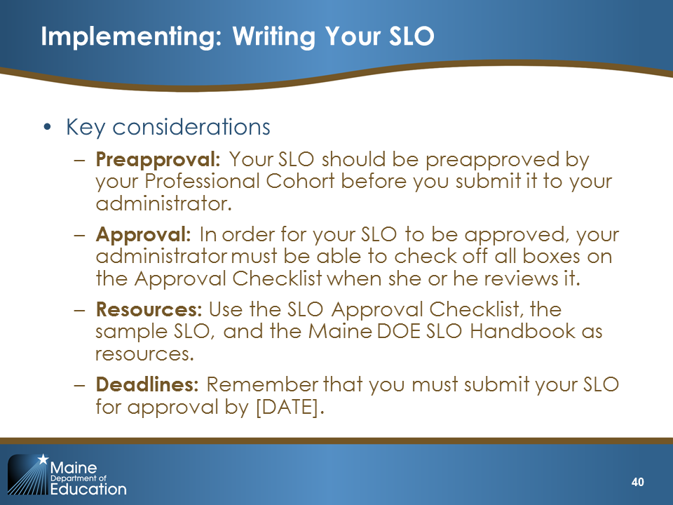  Slide 40

Implementing Activity 1: Writing Your SLO (45 minutes)

Purpose and Intended Outcomes
- Write a draft of an SLO
Explain:  “We asked you to bring various pieces of information with you today because we wanted to give you time to begin writing your SLO. We recommend that you sit with colleagues in similar grades and subjects so that you can ask questions and collaborate as needed.”  Read the directions on the slide. Explain that in 25 minutes, participants will swap SLOs with a colleague and provide feedback on the SLO. | 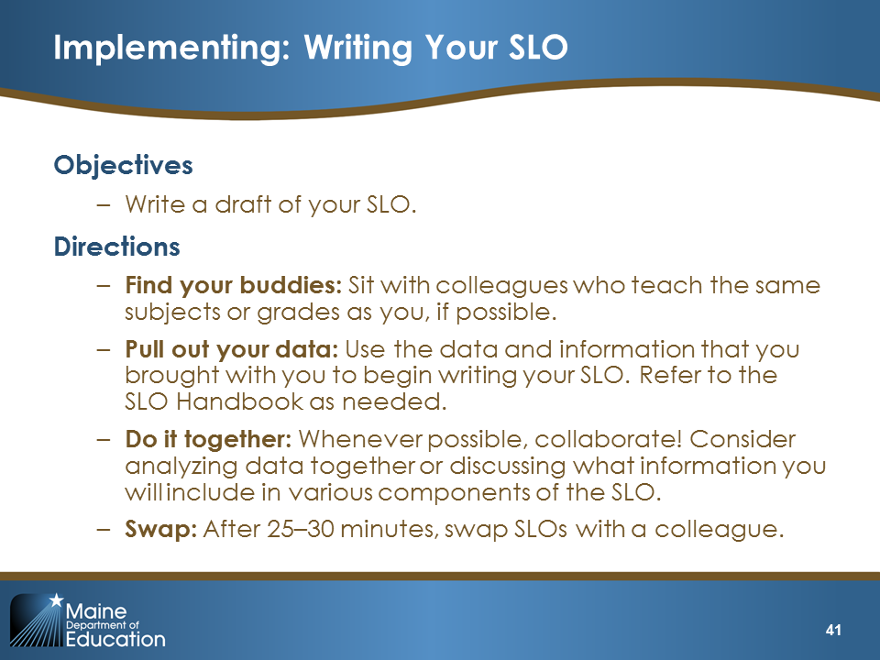  Slide 41
Possible Facilitation Challenges and Solutions
Challenge | Solution(s)
Some teachers have no data. | You may want to suggest that teachers who have no assessment data (e.g., art, PE, music teachers) use this time to begin writing an SLO that meets the criteria in the handbook and is based on content standards.
Teachers need additional assistance setting growth targets. | Pull a small group aside and provide guidance related to growth targets.
Participants do not seem engaged or on task. | Remind participants that we built this time into the training so that they would not have to write the SLO completely on their own time. Explain that getting started is really important because it will give them an opportunity to receive constructive feedback on their draft.

Implementing Wrap-Up/Debrief 2
After 25 to 30 minutes of writing, have participants swap SLOs with someone next to them. Each participant should read the SLO and then provide some feedback to the participant. If there is additional time, participants should brainstorm ways they can address the challenges they encountered during the process. | 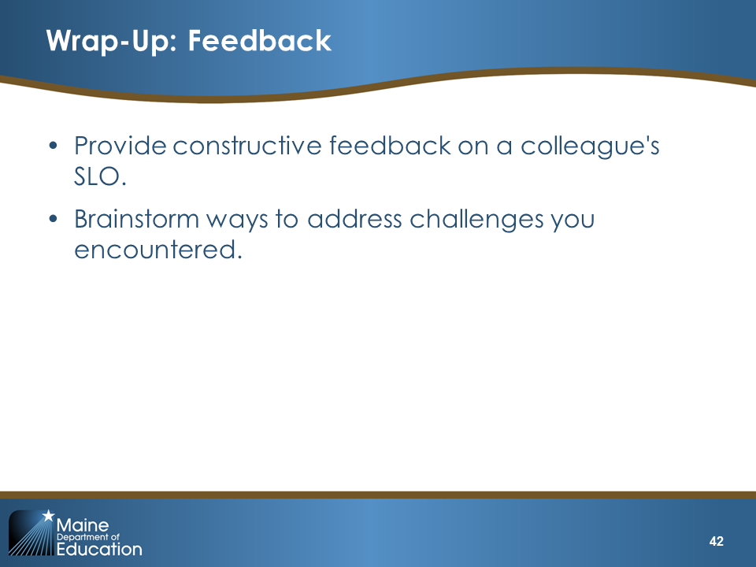  Slide 42

V. Reflecting (10 minutes)
Slide 43 is the title slide for the “Reflecting” section.
If there is enough time left, you can have them participate in this activity either at their tables or (if they need to move around) as a four-corner activity. If you decide to do it as a four-corner activity, post a piece of chart paper in each corner of the room and place a question number on each chart (1–4). Have participants rotate around the room answering each question.  Read slide. | 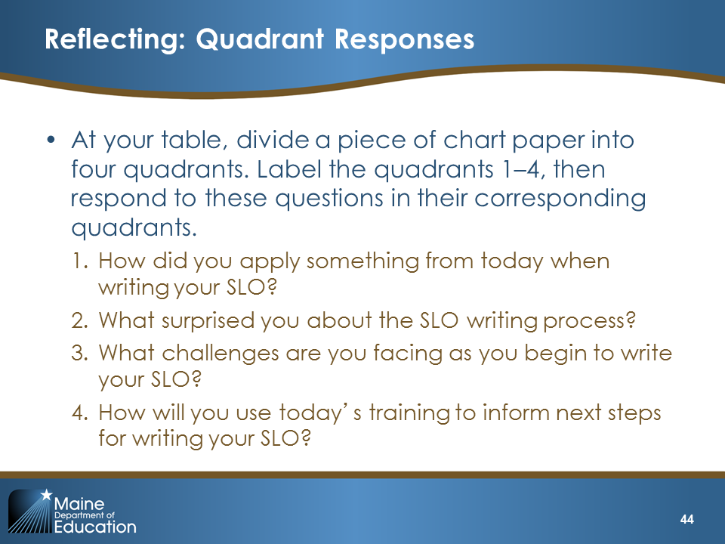  Slide 44

VI. Wrap-Up (10 minutes)
Slide 45 is the title slide for the “Wrap-Up” section.

What’s Next (5 minutes)
Explain:  “In Module 3, we’re going to focus on reflection and goal setting. The starting point for your professional goal is your students’ learning goals. Where do you need to grow to help your students meet the growth targets in your SLO? Your professional goals, which will be different from your student learning goals, should align with your SLO. In addition, you will learn how to reflect on your practice by considering evidence of your practice against the MSFE Rubric. Both your self-reflection and your SLO will help you to set SMART goals (specific, measurable, achievable, relevant, and time-bound goals). The module finishes by helping you prepare to submit both your SLO and your SMART goals for approval.” | 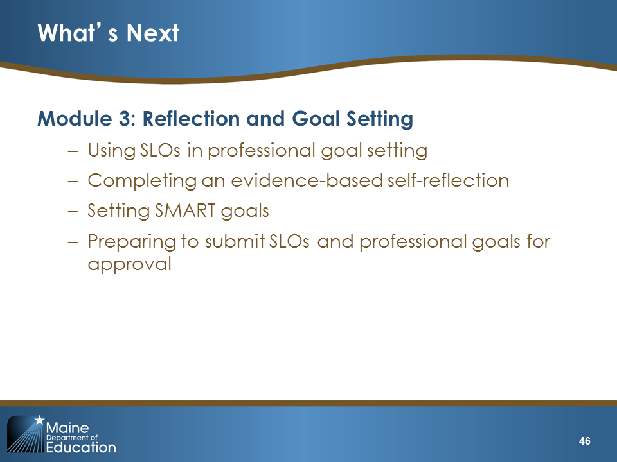  Slide 46

Suggested Assignment
If participants complete these assignments, they will be on track for having all the pieces of the evaluations completed on time.
Explain:  “We ask that you do two things to prepare for the next module. First, complete, review, and revise your SLOs. Focus especially on how your instructional plan in your SLO can be supported by the practices described in the Core Propositions and standard indicators in the MSFE Rubric. You will be using your SLO as part of your professional goal-setting process.” | 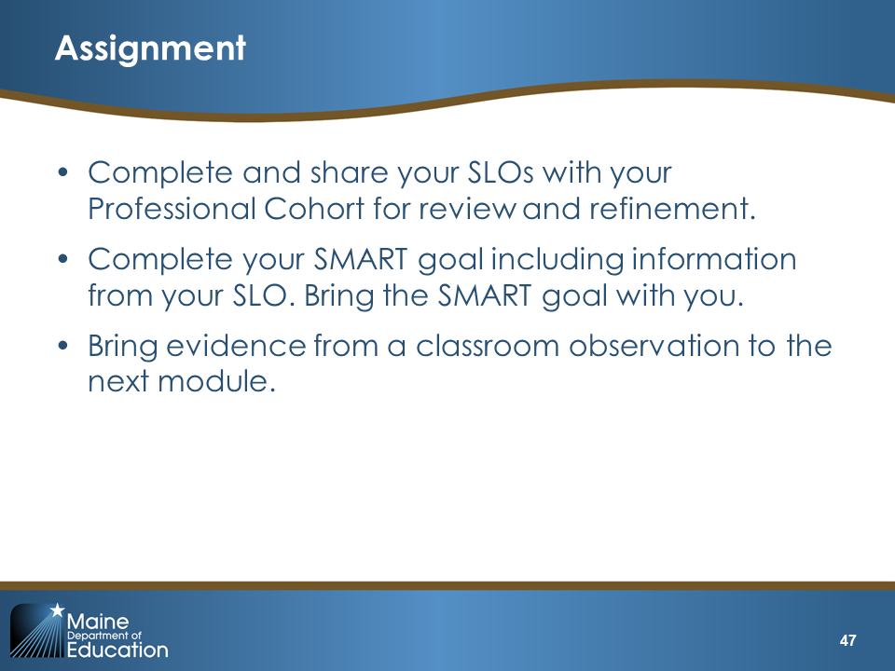  Slide 47
Come to Closure  Note: Enter your e-mail address on this final slide so that participants know where to send questions. | 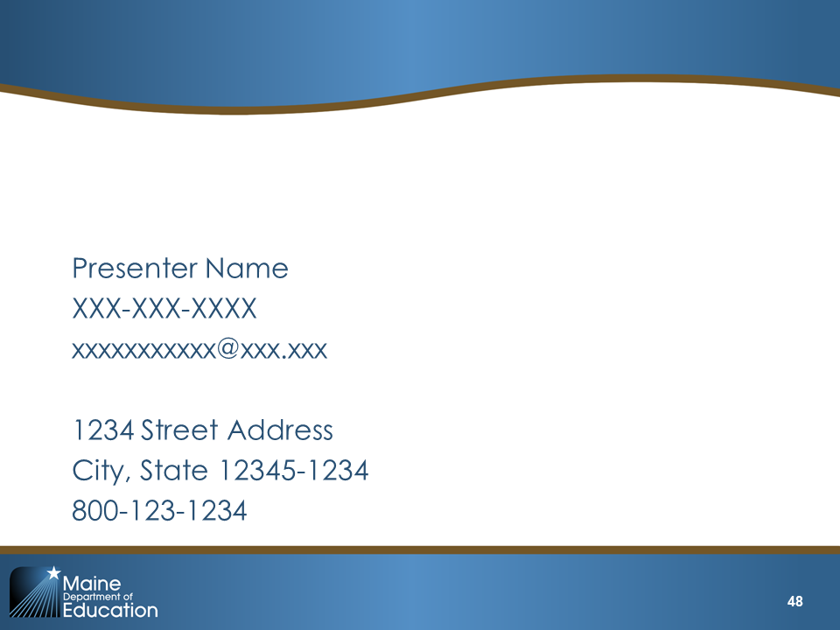  Slide 48

