The Application Director needs to change the status to Revision Started. They are the only one that are able to do this step.

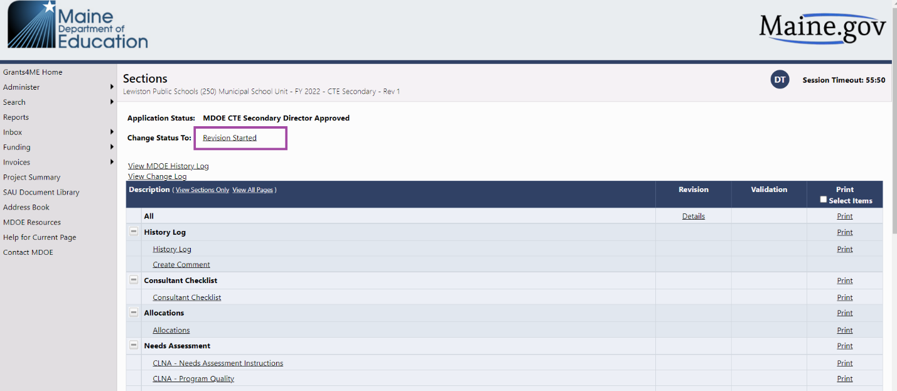
And select Confirm
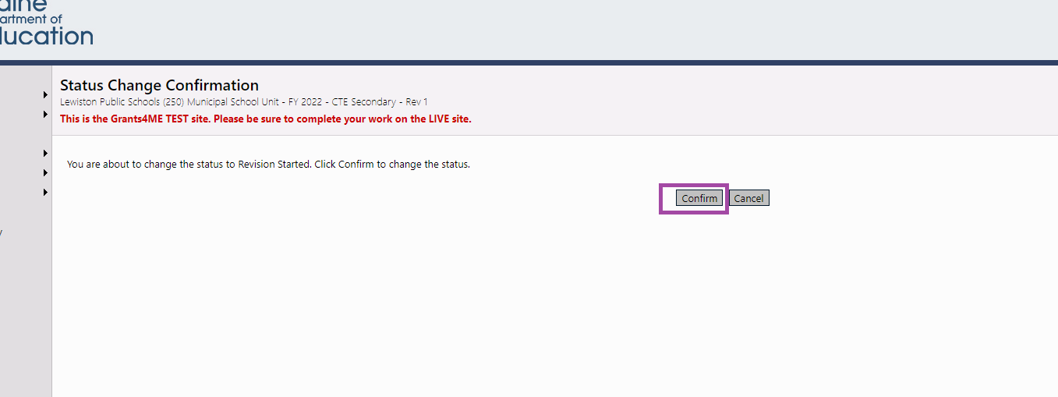

Then select Budget (this is the only section you can revise.
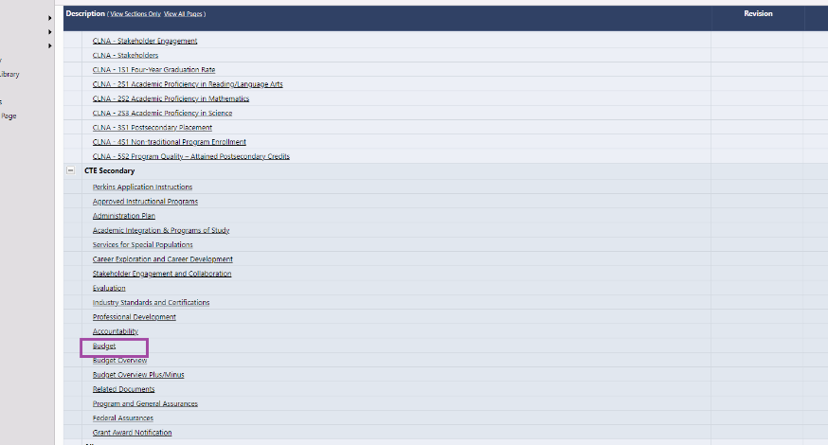
Click on modify for the budget you want to change.
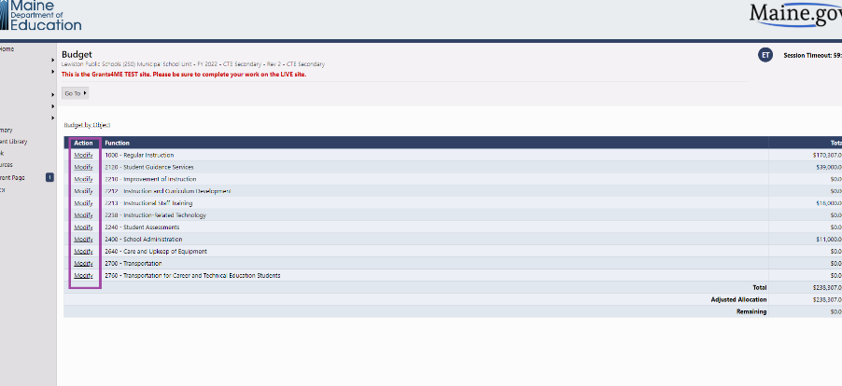

Select the pencil next to the activity you need to edit. This part is exactly the same process you did when writing you grant application.
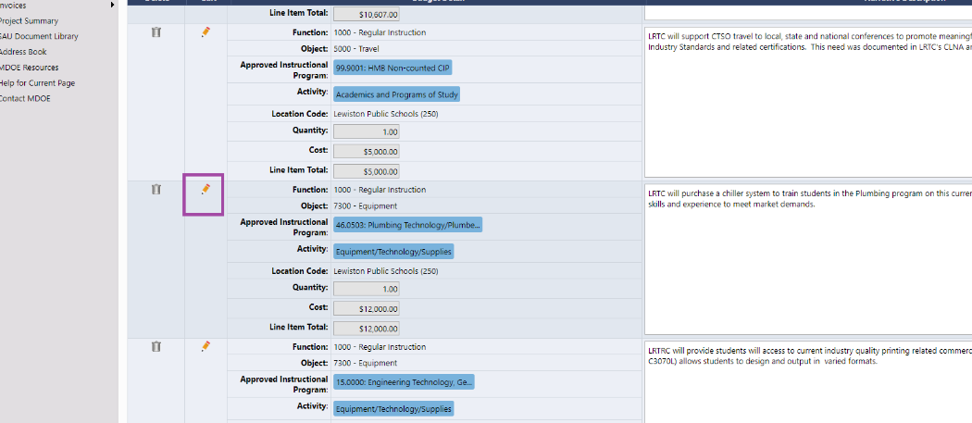

To create a new activity click on Add Budget Detail.
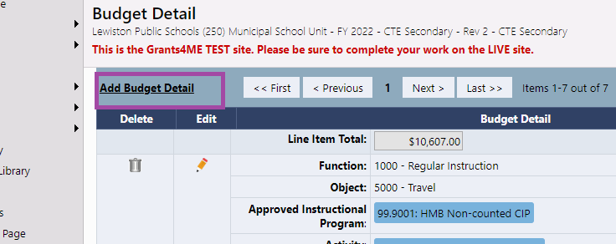

Select the trashcan next to the activity you need to delete.
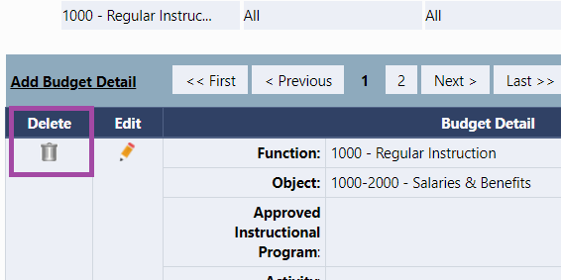
Once all the changes are made the Application Director needs to go to the Sections page and change the Status to Revision Completed to submit into the system. Again the Application Director is the only one that can do this step.
